SOLAR ENERGY AS A DRIVER OF SUSTAINABLE DEVELOPMENT – Technological and Market Cooperation Accelerates the Transition
Isak Karabegović
Academy of Sciences and Arts of Bosnia and Herzegovina
Bistrik 7, 71000 Sarajevo
Bosnia and Herzegovina
Email: isak1910@hotmail.com
Abstract: In a time marked by climate change and the depletion of natural resources, solar energy is increasingly recognized as a key driver of sustainable development. This paper analyzes the role of solar energy in the energy transition, focusing on its technical capabilities, economic benefits, and potential for job creation. Furthermore, it explores how the synergy between technological advancement and market mechanisms can accelerate the replacement of fossil fuels and contribute to the reduction of greenhouse gas emissions. The technical section outlines recent progress in photovoltaic technologies, improvements in solar panel efficiency, cost reductions in production, and the role of smart grids in integrating renewable sources into the energy system. Through an analysis of market trends, the importance of investments in renewable energy, subsidy mechanisms, tax incentives, and public-private partnerships in expanding solar capacity is emphasized. From an economic perspective, the paper explores the potential of the solar industry to create jobs—ranging from manufacturing and installation to maintenance and research. Utilizing available statistical data and models, the study demonstrates that investments in the solar sector yield multiple benefits: energy sovereignty, reduced dependence on fossil fuel imports, and the creation of new economic opportunities in both rural and urban areas. Case studies from countries that have successfully implemented solar strategies (e.g., Germany, Spain, and India) highlight key success factors and foreseeable obstacles that can be addressed proactively. Special attention is given to the role of public policy and regulatory frameworks that support the faster integration of solar energy, as well as the need for education and workforce retraining in accordance with the demands of the new energy paradigm. The paper concludes that synchronized efforts between technological development and market instruments are essential for accelerating the green transition. Solar energy, as a clean, renewable, and increasingly accessible resource, has the potential not only to replace fossil fuels but also to become a foundation for economic resilience and social equity in a post-carbon society.
Keywords: energy transition, solar energy, sustainable development, green jobs, market mechanisms, emission reduction

1. INTRODUCTION
The global energy sector is undergoing a dynamic and profound transformation, driven by the increasing need to address climate change, reduce dependency on fossil fuels, and enable sustainable development. Energy systems that rely on fossil fuels—such as coal, oil, and natural gas—are becoming increasingly problematic due to their harmful environmental impact, limited availability, and growing geopolitical and economic risks. The rise in greenhouse gas emissions, primarily carbon dioxide (CO₂), accelerates global warming and disrupts ecosystem balance, manifesting in frequent climate extremes and socio-economic disturbances [1]. In this context, solar energy is gaining increasing significance as a key component of a sustainable energy future. As a renewable, inexhaustible, and environmentally friendly energy source, solar energy has the potential to meet a significant portion of global electricity demand without the negative consequences associated with the use of fossil fuels [2]. Its growing importance lies in the fact that it facilitates the simultaneous achievement of ecological, technological, and economic goals of sustainable development [12]. The implementation of solar systems is not only a technical challenge, but also involves socio-economic, political, and regulatory aspects. Advancements in photovoltaic (PV) technologies, energy storage, and integration with smart grids have contributed to better efficiency and competitiveness of solar solutions [3,4]. Concurrently, market mechanisms such as subsidies, tax incentives, power purchase agreements, and carbon trading schemes are accelerating the commercialization of solar energy and attracting private investments [5,13]. From an economic perspective, the solar industry represents an important generator of jobs throughout the value chain—from research and equipment manufacturing to system installation, management, and maintenance. Unlike traditional energy models that are highly centralized and require large capital investments, solar technology enables decentralization and more equitable distribution of benefits, including in marginalized communities [8,9]. According to IRENA (2022) predictions, the renewable energy sector could generate over 38 million new jobs by 2030, with solar energy leading the way [6]. In addition to its ecological and economic benefits, solar energy directly contributes to the realization of several United Nations Sustainable Development Goals (SDGs), including Goal 7 (Affordable and Clean Energy), Goal 8 (Decent Work and Economic Growth), and Goal 13 (Climate Action). Its ability to reduce energy inequality, enable greater energy independence, and foster technological innovation positions it as a cornerstone of sustainable development policies [10,11]. However, despite its growing significance, the wider implementation of solar energy faces numerous challenges, such as high upfront investment costs, intermittency in energy production, inconsistent regulatory frameworks, and the need for skilled labor. Overcoming these barriers requires systemic cooperation between technological innovations and market instruments, as well as proactive government involvement [7].
The aim of this paper is to explore the technical advances and economic potential of solar energy within the context of the green transition and sustainable development [14]. Special focus is placed on how coordinated efforts between technology innovators, market actors, and regulatory institutions can accelerate the shift to more energy-efficient, cleaner, and resilient systems. The paper also analyzes the contribution of the solar industry to job creation and the promotion of inclusive economic growth, particularly in communities vulnerable to climate and economic risks.

2. TECHNOLOGICAL ADVANCEMENTS IN SOLAR ENERGY
Solar energy, as one of the most promising renewable energy sources, has undergone dynamic development over the past few decades. The evolution of photovoltaic (PV) cell technology, improvements in efficiency, reductions in manufacturing costs, and integration with smart grids have become key factors enabling faster and more efficient implementation of solar systems worldwide.

2.1. Evolution of Solar Technologies: From Early PV Cells to Modern Innovations
The first functional photovoltaic cells were developed in 1954 at Bell Laboratories, with an initial efficiency of only around 6% [15]. Over the following decades, research efforts led to significant innovations in cell design, the use of new materials, and optimization of manufacturing processes, as shown in the block diagram shown in Figure 1. Today, several generations of PV technologies exist:
- First-generation PVs include crystalline silicon cells (both mono- and polycrystalline), which dominate the market due to their stability and relatively high efficiency.
- Second-generation technologies consist of thin-film solar cells (such as amorphous silicon, CdTe, and CIGS), which offer greater flexibility and lower production costs, albeit with slightly reduced efficiency.
- Third-generation technologies involve advanced concepts such as perovskite solar cells and multi-junction devices, aiming for efficiencies exceeding 30% [16].
This technological evolution has enabled the diversification of solar energy applications, including building-integrated photovoltaics (BIPV) and the development of flexible and transparent modules for novel uses [17,18].

2.2. Efficiency, Costs, and New Generations of Solar Panels
The efficiency of PV cells has continued to improve thanks to advancements in materials science and manufacturing techniques. Commercial monocrystalline cells today achieve efficiencies above 22%, while research laboratories have developed tandem and perovskite-silicon cells reaching up to 30% [19]. Simultaneously, the cost of solar energy has drastically decreased: the average cost of PV system installation has dropped by more than 80% over the past decade [20].
New generations of solar panels are combining high efficiency with increased durability, reduced environmental impact, and improved performance under low-light conditions, thereby enhancing their competitiveness against conventional fossil-fuel-based energy sources.

2.3. Integration of Smart Grids and Energy Storage
The accelerated development of solar technology must be viewed alongside innovations in energy grid systems. Traditional electricity grids, designed for unidirectional energy flow, were not prepared for the decentralized generation enabled by solar energy. The integration of smart grids allows for bidirectional energy flow and real-time communication between producers and consumers, while energy storage systems (such as lithium-ion batteries) assist in balancing generation and consumption [21,22].
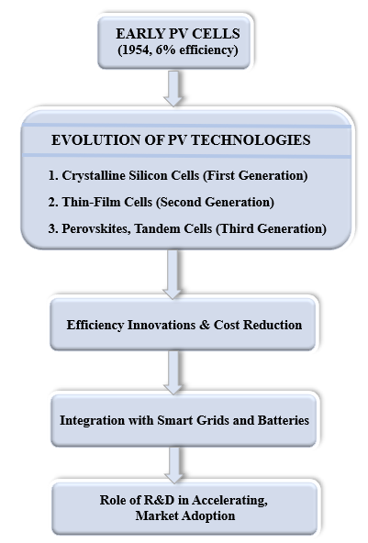
Figure 1. Evolution and progress Factors of Solar Energy
Together, these technologies enable greater grid stability, enhanced flexibility, and maximize the utilization of generated solar energy, thus reducing the need for costly backup capacities from conventional power plants.

2.4. The Role of Research and Development (R&D) in Accelerating Implementation
Research and development (R&D) remain the cornerstone of innovation in the solar energy sector. Continued investments in R&D have enabled the discovery of new materials (e.g., tandem cells), improvement in production processes, and optimization of system performance.
Public-private partnerships, national innovation strategies, and international collaborations further accelerate the transition of laboratory breakthroughs into commercial products [17,19].
Moreover, R&D increasingly includes interdisciplinary approaches, focusing on the environmental sustainability of materials and the recycling of solar panels, which will be crucial for the long-term viability of the sector.

3. TRENDS IN THE UTILIZATION AND GLOBAL DEVELOPMENT OF SOLAR ENERGY
Solar energy, as the most widespread form of renewable energy, is increasingly occupying a central position in global energy strategies. The natural abundance of solar radiation, combined with continuous technological advancements and declining costs of photovoltaic (PV) systems, has driven the dynamic growth of global solar energy use. According to the International Energy Agency (IEA), over the past decade, solar energy has recorded the highest growth rate among all renewable energy sources, with the potential to become the dominant source of energy in the coming decades [23].
One of the primary drivers behind the expansion of solar energy is the geographical distribution of solar radiation, enabling implementation across a broad range of climatic conditions. Although countries with high insolation levels, such as Australia, Middle Eastern nations, and parts of Africa, are naturally predisposed to solar development, significant growth in installed capacities has also been observed in regions with temperate climates, thanks to advancements in PV technology efficiency [24]. Trends in the use of solar energy are also reflected in the diversification of applications. Beyond traditional large-scale solar farms, there is a growing proliferation of distributed solar systems, including rooftop installations on residential, industrial, and public buildings. This trend has enabled users to become "prosumers"—simultaneously producers and consumers of energy—thus enhancing grid stability and improving local energy security [25].

3.1. Trends in Global Solar Energy Capacities
In the context of increasingly severe climate change, pollution, and resource depletion, solar energy emerges as a key solution for a sustainable future. Through the development of solar technologies, public education, and appropriate legislation, it is possible to build a healthier and more resilient planet.
The trends in global development of photovoltaic (PV) capacities from 2012 to 2022 are illustrated in Figures 2 and 3 [26-28].
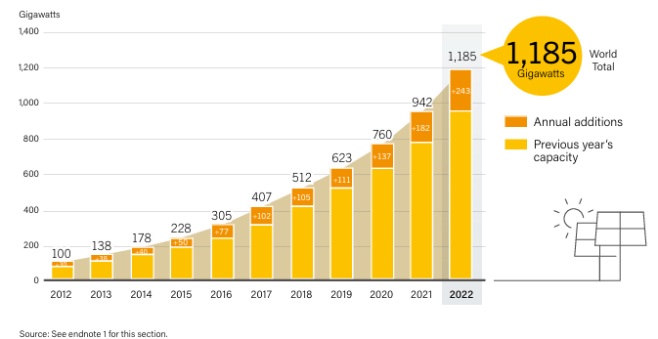
Source: See endnote 1 for this section.
Figure 2. Trend of Global Solar PV Capacity (2012–2022)
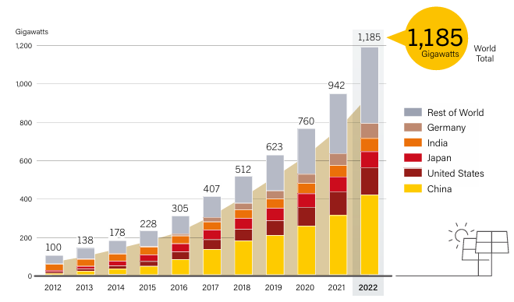
Source: See endnote 9 for this section.
Figure 3. Trend of Solar PV Capacity by Country and Region (2012–2022)
Solar PV generation accounted for 6.2% of global electricity production in 2022. Spain (19.1%), Greece (17.5%), Chile, the Netherlands, and Germany recorded the highest shares of solar energy in their electricity mixes. Centralized PV systems added 124.8 GW of new installations, while distributed systems added 115.2 GW, largely driven by the decline in module prices.
The top five markets for additional capacity included Germany, Japan, Poland, Australia, and the Netherlands (Figure 4). Meanwhile, China, the United States, Japan, India, and Germany continue to lead in total installed capacity (Figure 5) [26-28].
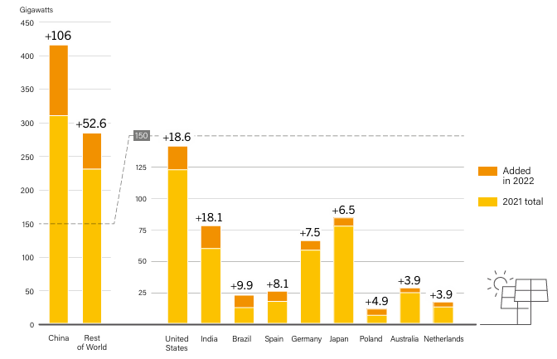
Figure 4. Additional PV Capacity in the Ten Leading Countries in 2022
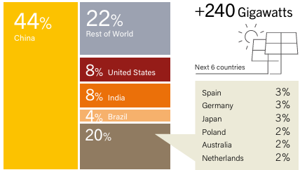
Figure 5. Cumulative Solar PV Capacity by Country
Source: See endnote 1.
In 2022, several countries introduced measures to stimulate the development of rooftop solar systems. Examples include tax reductions in Germany and Belgium, increased subsidies in Norway, and streamlined permitting processes in Italy, Spain, and Portugal. China’s solar market experienced a boom, adding approximately 106 GW of new capacity, of which 58% came from distributed systems. The country’s total installed capacity reached 414.5 GW, with robust growth in both centralized and distributed sectors. India ranked as the third-largest market globally, adding 18.1 GW, although still falling short of planned targets. Japan maintained stable growth, with Tokyo announcing mandatory solar panel installations for new buildings starting in 2025. In the field of concentrated solar power (CSP), global capacity increased by 200 MW to a total of 6.3 GW (Figure 6) [26-28]. Although leading markets such as Spain and the United States have stagnated, new projects are underway in Chile, China, Israel, Morocco, and South Africa.
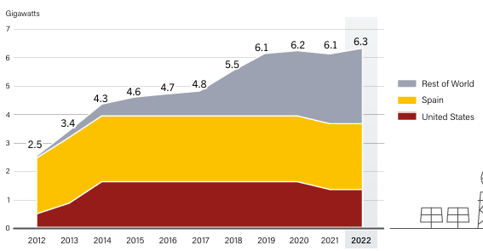
Source: See endnote 1 for this section.
Figure 6. Global CSP Capacity (2012–2022)
The solar thermal industry faced supply chain challenges and competition from alternative technologies such as PV and heat pumps. Nevertheless, there is a growing interest in large-scale projects and hybrid systems within industrial sectors and energy grids. By 2022, the total global capacity of solar thermal systems reached 542 GWth, sufficient to produce approximately 442 TWh of heat annually (Figure 7) [26-28].
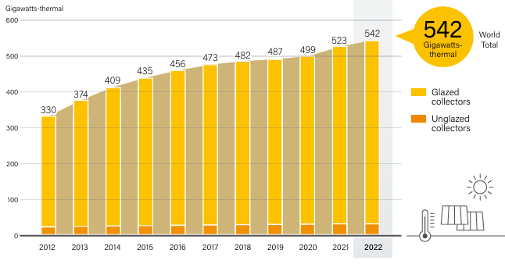
Source: IEA SHC. See endnote 10 for this section. Note: Data are for glazed and unglazed solar water collectors and do not include concentrating, air or hybrid collectors.
Figure 7. Global Capacity of Solar Collectors for Water Heating (2012–2022)
Over the past decade, both solar PV and CSP technologies have made significant strides, becoming key pillars of the global energy transition. Thanks to cost reductions, efficiency improvements, and market expansion, solar energy increasingly contributes to a more stable and sustainable global energy system. According to the International Renewable Energy Agency (IRENA), the total installed solar capacity worldwide reached 1.2 terawatts (TW) by the end of 2024, nearly tripling compared to 2019 [28]. The largest contribution to this growth came from China, which currently accounts for more than 35% of global PV installations, followed by the United States, India, and EU countries [29-31]. Incentive policies—such as subsidies, tax incentives, and feed-in tariff schemes—have been instrumental in accelerating the commercialization of solar technologies. Furthermore, the development of advanced energy storage systems, particularly battery technologies, is helping to mitigate intermittency challenges, thereby enhancing the reliability of solar energy supply [32]. Nevertheless, several challenges remain. Rising raw material prices for PV module production, the recycling of aging systems, and the need for improvements in grid infrastructure are critical areas requiring further research and innovation [33-35]. Additionally, socioeconomic factors and unequal investment opportunities between developed and developing nations may further influence the dynamics of the global transition to solar energy. In conclusion, global trends clearly indicate that solar energy already plays—and will continue to play—a pivotal role in decarbonizing energy sectors. Further technological advancements, strategic investments, and international cooperation will be crucial for achieving sustainable and equitable development of solar energy worldwide.

4. SYNERGISTIC EFFECTS OF TECHNOLOGICAL INNOVATIONS AND MARKET MECHANISMS IN ACCELERATING THE SUSTAINABLE ENERGY TRANSITION

4.1.Interaction Between Technological Innovations and Market Needs
The synergistic interaction between innovative technological solutions and the evolution of market needs has become a key driver in the process of sustainable energy transition. Recent advancements in the fields of distributed energy resources, energy storage, and the digitalization of grid systems reflect the increasing market demand for reliable, accessible, and low-carbon energy sources [36,37]. Concurrently, market signals, shaped by decarbonization policies and a growing societal orientation towards sustainability, are steering research and development efforts towards solutions that enable faster integration of renewable energy sources into energy systems.

Table 1 summarizes the dynamic relationship between technological innovations, evolving market demands, and the key actors facilitating the energy transition.
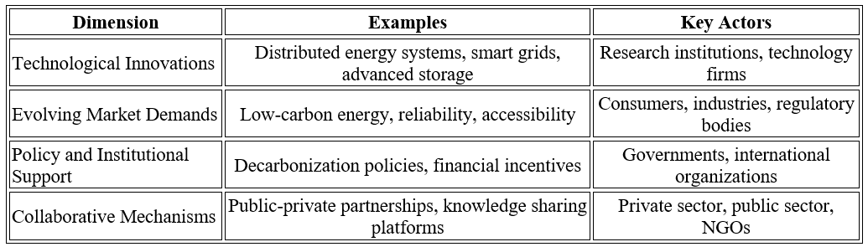
Source: Adapted from [37,38,40]
Following the tabular representation of the dynamic relationship between technological innovation, market evolution, and institutional actors, Figure 8 visually highlights the key drivers that synergistically accelerate the sustainable energy transition.
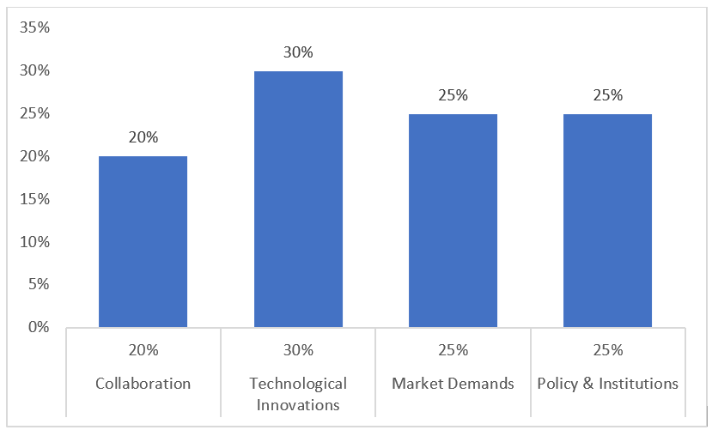
Figure 8. Key Drivers of the Sustainable Energy Trausition
Figure 8 illustrates the relative importance of key drivers in accelerating the sustainable energy transition. This distribution highlights the need for an integrated approach combining technology, market adaptation, and institutional support.Technological innovations account for the largest share among the drivers, emphasizing the critical role of research and technological progress. Market demands and policy frameworks contribute equally to shaping the transition, while collaborative mechanisms between public and private sectors serve as vital enablers for effective system-wide transformation.

4.2. Public-Private Partnerships as Agents of Transformation
Public-private partnerships (PPP) have emerged as an indispensable instrument for mobilizing investments and disseminating innovative technologies within the energy sector. Collaboration models involving joint financing of infrastructure projects, pilot initiatives, and development programs significantly contribute to risk reduction for the private sector and facilitate the efficient implementation of new solutions [38]. Particularly in the field of renewable energy, the combination of regulatory incentives and private sector innovations has demonstrated a high degree of success in transitioning from centralized to distributed production models.

4.3. The Role of International Organizations and Global Initiatives
International institutions, including the International Energy Agency (IEA), the International Renewable Energy Agency (IRENA), and the framework of the United Nations Sustainable Development Goals (SDGs), provide normative guidelines, technical assistance, and financial support mechanisms for countries undergoing energy transition processes. Their activities enable the coordination of global efforts, the harmonization of regulatory frameworks, and the transfer of best practices among nations [39]. Reports and recommendations issued by these bodies play a particularly significant role, serving as the foundation for the formulation of national energy policies and investment strategies.

4.4. Future Development Perspectives: Decentralization, Energy Communities, and Smart Cities
Future perspectives for sustainable energy transitions point towards increasing decentralization of energy production and distribution, based on principles of participatory governance and local autonomy. The development of energy communities enables citizens and small businesses to actively participate in energy generation and sharing, thereby strengthening system resilience and fostering social inclusion [40]. Simultaneously, the concept of smart cities, grounded in the integration of information and communication technologies (ICT) into infrastructure, optimizes energy consumption management with the aim of reducing greenhouse gas emissions and improving efficiency [41]. These approaches lay the foundations for the creation of sustainable urban environments capable of adapting to the challenges posed by climate change.
5.CONCLUSION
Solar energy has emerged as a critical pillar in the global transition towards sustainable development, offering a clean, renewable, and increasingly cost-effective solution to the challenges posed by climate change and resource depletion. The rapid advancements in photovoltaic technologies, coupled with reductions in production costs and enhanced efficiencies, have significantly expanded the potential of solar energy to replace fossil fuels across diverse sectors. These technological innovations, when combined with market mechanisms such as subsidies, tax incentives, and public-private partnerships, have created a dynamic ecosystem that accelerates the adoption of solar solutions globally. The integration of smart grids and energy storage systems further strengthens solar energy's role by enhancing grid stability and enabling the efficient management of decentralized energy generation. As a result, solar energy not only contributes to reducing greenhouse gas emissions but also promotes energy sovereignty, reduces dependence on fossil fuel imports, and creates new economic opportunities through job creation in manufacturing, installation, and maintenance. These economic benefits extend to both rural and urban communities, highlighting solar energy’s potential to foster inclusive economic growth and social equity. Despite the substantial progress, several challenges remain, including high upfront investment costs, energy intermittency, and the need for skilled labor. Overcoming these barriers requires coordinated efforts between technological innovators, market stakeholders, and policymakers. The role of public policy and international cooperation, alongside proactive government involvement, is paramount in accelerating the transition to solar energy and achieving long-term sustainability goals. In conclusion, solar energy’s growing importance in the global energy mix is not only driven by its environmental and economic benefits but also by its potential to underpin a resilient, equitable, and decarbonized energy future. By harnessing the synergies between technological advancements and market dynamics, solar energy can serve as a foundational element of the green transition, leading to a more sustainable and prosperous global society.
References:
[1] | IEA (2022). World Energy Outlook 2022. International Energy Agency.; https://www.iea.org/
[2] | Abd Aziz AJ, Baharuddin NA, Khalid RMd, Kamarudin SK. Review of the policies and development programs for renewable energy in Malaysia: Progress, achievements and challenges. Energy Exploration & Exploitation. 2024;42(4):1472-1501. doi:10.1177/01445987241227509
[3] | Breyer, C., et al. (2021). On the role of solar photovoltaics in global energy transition scenarios. Progress in Photovoltaics: Research and Applications, 29(6), 505–523.https://doi.org/10.1002/pip.2885
[4] | Haegel, N., Feldman, D., Kroposki, B., Margolis, R., Tumas, W., Woodhouse, M., Kurtz, S., Buonassisi, T., Frotzheim, A., Garabedian, R., Green, M., Glunz, S., Henning, H.-M., Holder, B., Kaizuka, I., Matshubara, K., Niki, S., Sakurai, K., Schindler, R., ... Wilson, G. (2017). Terawatt-Scale Photovoltaics: Trajectories and Challenges. Science, 356(6334), 141-143. https://doi.org/10.1126/science.aal1288
[5] | IRENA (2021). Renewable Energy Market Analysis: Southeast Asia. International Renewable Energy Agency.; https://www.irena.org/
[6] | IRENA (2022). Renewable Energy and Jobs – Annual Review 2022. Abu Dhabi.https://www.irena.org/
[7] | Kabir, E., et al. (2018). Solar energy: Potential and future prospects. Renewable and Sustainable Energy Reviews, 82(1), 894–900. https://doi.org/10.1016/j.rser.2017.09.094
[8] | Karabegović, I., (2016). Applications of Renewable Energy Sources in the World and the EU wirt a Particular Focus on Solar Energy, International Journal of Advanced Engineering Research and Science, Vol.3., Iss.11., pp.224-228. ;https://dx.doi.org/10.22161/ijaers/3.11.34.
[9] | Güler, İ., Atan, M. & Adalı, Z.,(2024). The effect of economic growth, investment, and unemployment on renewable energy transition: evidence from OECD countries. Environ Sci Pollut Res 31, 52001–52016 . https://doi.org/10.1007/s11356-024-34143-7
[10] | Rajesh, C. Majid, A.M., Renewable energy for sustainable development in India: current status, future prospects, challenges, employment, and investment opportunities, Energy, Sustainability and Society, 10(2), :1-36.; DOI:10.1186/s13705-019-0232-1
[11] | Padhan, L., & Bhat, S. (2025). The relevance of renewable energy and green innovation in environmental sustainability: Evidence from BRICS countries. International Journal of Sustainable Economy, 17(1), 52–74.; DOI: 10.1504/IJSE.2025.142926
[12] | Ismail, A. M., Ramirez-Iniguez, R., Asif, M., Munir, A. B., & Muhammad-Sukki, F. (2015). Progress of solar photovoltaic in ASEAN countries: A review. Renewable and Sustainable Energy Reviews, 48, 399–412.; https://doi.org/10.1016/j.rser.2015.04.010
[13] | Bölük, G., Kaplan, R. Effectiveness of renewable energy incentives on sustainability: evidence from dynamic panel data analysis for the EU countries and Turkey. Environ Sci Pollut Res 29, 26613–26630 (2022). https://doi.org/10.1007/s11356-021-17801-y
[14] | Karabegović, I., and Doleček, V.,(2013). Current state and prospects for renewable energy sources with a special emphasis on potential of solar energy in the World, Europe and Bosnia and Herzegovina, Contemporary Materials (Renewable Energy Sources), Vol. IV. No. 2. pp. 171-179.  http://www.savremenimaterijali.info/index.php?idsek=28
[15] | Green, M.A., Dunlop, E.D., Hohl-Ebinger, J., Yoshita, M., Kopidakis, N. and Ho-Baillie, A.W.Y. (2020) Solar Cell Efficiency Tables (Version 55). Progress in Photovoltaics: Research and Applications, 28, 3-15.; https://doi.org/10.1002/pip.3228
[16] | Kojima, A., Teshima, K., Shirai, Y. and Miyasaka, T. (2009) Organometal Halide Perovskites as Visible-Light Sensitizers for Photovoltaic Cells. Journal of the American Chemical Society, 131, 6050-6051.; https://doi.org/10.1021/ja809598r
[17] | Zhao, Y., & Zhu, K. (2016). Organic–inorganic hybrid lead halide perovskites for optoelectronic and electronic applications. Chemical Society Reviews, 45(3), 655-689.  https://doi.org/10.1039/C4CS00458B
[18] | Karabegović, I., 2017, Applications Trend of Renewable Energy Sources for Energy Production in the World Wirt Special Reference to Wind Power , International Journal of Materials Protection, Vol.58., No.1., doi:10.5937/ZasMat1701086K; www.idk.org.rs/casopis-zastiza-materijala/).
[19] | Yang, W. S., et al. (2017). Iodide management in formamidinium-lead-halide–based perovskite layers for efficient solar cells. Science, 356(6345), 1376-1379.; DOI:10.1126/science.aan2301
[20] | IRENA. (2020). Renewable Power Generation Costs in 2019. International Renewable Energy Agency Report, https://www.irena.org/
[21] | Lopes, J. A. P., Hatziargyriou, N., Mutale, J., Djapic, P., & Jenkins, N. (2007). Integrating distributed generation into electric power systems: A review of drivers, challenges and opportunities. Electric Power Systems Research, 77(9), 1189-1203. ; https://doi.org/10.1016/j.epsr.2006.08.016
[22] | Karabegović, I., Doleček, V.(2015) Development and Implementation of Renewable Energy Sources in the World and European Union, Contemporary Materials (Renewable Energy Sources), Vol. VI. No. 2. pp. 130-148. http://www.savremenimaterijali.info/index.php?idsek=28
[23] | International Energy Agency (IEA). (2023). Renewables 2023: Analysis and forecast to 2028. IEA. Retrieved from https://www.iea.org/reports/renewables-2023
[24] | Masson, G., Kaizuka, I., & Branker, K. (2022). Trends in Photovoltaic Applications 2022: Survey report of selected IEA countries between 1992 and 2021. International Energy Agency - Photovoltaic Power Systems Programme (IEA-PVPS). https://iea-pvps.org/
[25] | Karabegović. I., (2017). Applications Trend of Renewable Energy Sources for Energy Production in the World Wirt Special Reference to Wind Power , International Journal of Materials Protection, Vol.58., No.1., pp:86-93. doi:10.5937/ZasMat1701086K; www.idk.org.rs/casopis-zastiza-materijala/.
[26] | Renewable 2024 Global Status Report, Paris: REN21 Secretariat, 2024. https://www.ren21.net/
[27] | Renewable 2023 Global Status Report, Paris: REN21 Secretariat, 2023. https://www.ren21.net/
[28] | International Renewable Energy Agency (IRENA). (2024). Renewable Capacity Statistics 2024. IRENA. https://www.irena.org/
[29] | Zhang, Y., Sun, X., Xu, Y., & Zhang, L. (2023). The role of China’s solar PV development in global energy transition. Energy Policy, 178, 113563. https://doi.org/10.1016/j.enpol.2023.113563
[30] | Karabegović, I., (2018). The Tendency of Application of Renewable Energy Sources in the World, Scientific Profesional Journal, Iss.29, 2018, pp.7-18. http://www.diz.org.rs/images/casopis/dit29.pdf
[31] | Karabegović I., and Jovanović, J., (2017). The Representation of Renewable Energy Sources in the World and the European Union, Journal of Oil and Gas, Vol.37., Iss.151., pp.79-92. http://www.hunig.hr/sibenik2017/obnovljivi-izvori-energije.html
[32] | Luthander, R., Widén, J., Munkhammar, J., & Lingfors, D. (2015). Self-consumption of photovoltaic electricity in residential buildings: A review. Applied Energy, 142, 80–94. https://doi.org/10.1016/j.apenergy.2014.12.028
[33] | Alonso, E., Valle, F., & Martínez, E. (2023). Circular economy strategies for solar photovoltaic panels: A review. Renewable and Sustainable Energy Reviews, 176, 113205. https://doi.org/10.1016/j.rser.2023.113205
[34] | Zappa, W., Junginger, M., & van den Broek, M. (2022). Is a 100% renewable European power system feasible by 2050? Applied Energy, 233-234, 1027–1050. https://doi.org/10.1016/j.apenergy.2018.08.109
[35] | Haegel, N. M., et al. (2023). Terawatt-scale photovoltaics: Trajectories and challenges. Science, 384(6651), 50–58. https://doi.org/10.1126/science.abn6780
[36] | Karabegović. I., 2017, Potential of Bosnia and Herzegovina in Renewable Energy Sources-a Chance for New Jobs, Collequium Energy sector of Bosnia and Herzegovina at a crossroada, Special Editions Vol.CLXX, Vol.18. pp:93-97. http://www.anubih.ba/images/publikacije/posebna_izdanja/OTN/18_posebna_izdanja_CLXX_18_EnergetikaBiH.pdf).
[37] | Liu, Y., Yu, Y., Xu, Q., Chen, B., & Hao, H. (2021). Technological progress and market demand driving the global energy transition: A dynamic perspective. Renewable and Sustainable Energy Reviews, 143, 110903. https://doi.org/10.1016/j.rser.2021.110903
[38] | Sartor, O., & Bataille, C. (2019). Decarbonising Energy-Intensive Industries: The Road to a Climate-Neutral Europe. Climate Policy, 19(3), 375-391. https://doi.org/10.1080/14693062.2018.1464897
[39] | IRENA (2023). World Energy Transitions Outlook 2023: 1.5°C Pathway. International Renewable Energy Agency. Retrieved from https://www.irena.org/publications
[40] | Haf, S., Parkhill, K., McDonald, M., Hinton, E., & Henwood, K. (2020). The role of energy communities in sustainable energy transitions: An integrative review. Energy Research & Social Science, 68, 101556. https://doi.org/10.1016/j.erss.2020.101556
[41] | Moura, P., & De Almeida, A. T. (2022). Smart cities and energy transition: A framework for smart sustainable urban development. Sustainable Cities and Society, 76, 103352https://doi.org/10.1016/j.scs.2021.103352

