EVALUATION OF WASTE GLASS AS A PARTIAL GROWING MEDIUM REPLACEMENT FOR HORTICULTURAL PLANTS: A PILOT STUDY

Božidar Ilić¹, Svjetlana Zeljković², Saša Zeljković¹

¹ University of Banja Luka, Faculty of Natural Sciences and Mathematics, Department of Chemistry. Mladena
Stojanovića 2, Banja Luka, Republic of Srpska, e-mail: bozidar.ilic@student.pmf.unibl.org,
sasa.zeljkovic@pmf.unibl.org
² University of Banja Luka, Faculty of Agriculture, Bulevar vojvode Petra Bojovića 1 A,
Banja Luka, Republic of Srpska, e-mail: svjetlana.zeljkovic@agro.unibl.org

Abstract: Intensive agricultural and horticultural practices have accelerated the depletion of plant-available silicon in soils, increasing the demand for sustainable substrate alternatives and resource recovery strategies. This pilot study investigated the feasibility of utilizing mechanically processed consumer waste glass (soda-lime glass) as a partial replacement for conventional growing media. The waste glass was crushed and milled into fine particles with partially rounded edges to prevent root damage and was evaluated using a 630 µm sieve. Preliminary trials were conducted using bean (Phaseolus vulgaris) seedlings across three hydroponic treatments (0, 3, and 5% ground glass) and a parallel soil experiment (0% and 5% ground glass). These results indicate that the inclusion of waste glass does not inhibit root development. Hydroponic cultivation with 5% glass stimulated more pronounced lateral root formation and darker leaf coloration. Under soil conditions, the 5% glass substrate noticeably enhanced growth, increasing the average root length from 13.3 cm (control) to 20.3 cm. These preliminary findings suggest that waste glass can serve as a functional structural substrate component, potentially improving aeration, drainage, and possibly indicating gradual silicon delivery, although further larger-scale replication is needed to confirm its statistical significance and long-term biochemical effects.
Keywords: Waste glass, Circular economy, Growth medium, Silicon fertilization, Substrate aeration, Phaseolus vulgaris

- INTRODUCTION

Silicon is one of the most abundant elements in the Earth's crust, where it occurs predominantly as silicon dioxide (SiO₂). However, a major limitation to its utilization is that most silicon exists in chemically inert forms, rendering it unavailable for plant uptake [1]. Intensive agricultural practices accelerate the depletion of plant-available silicon from soils, making silicon deficiency an emerging concern in modern agriculture [2]. Although silicon is not considered an essential element for the primary metabolism of most plants, it is widely recognized as a beneficial nutrient because of its numerous positive effects on plant growth and productivity. In agriculture, silicon-based fertilizers are increasingly applied to mitigate both biotic and abiotic stresses that can adversely affect crop yield and quality. Silicon contributes to the increased structural integrity of plant tissues, reduces water loss by improving stress tolerance, immobilizes toxic metal ions through co-precipitation and complexation, and enhances plant defense responses by stimulating immune and protective mechanisms. [1-3]
In response to the increasing depletion of plant-available silicon in soils, alternative sources of silicon, particularly silicon-based fertilizers produced from waste materials, have attracted considerable attention [4]. Among these, glass frit has emerged as a promising eco-friendly slow- and controlled-release fertilizer [4]. Its application aims to address the environmental challenges associated with conventional fertilizers, including water and soil contamination caused by the rapid dissolution and leaching of nutrients such as nitrogen and phosphorus [4]. Furthermore, the utilization of waste-derived glass frit supports the principles of green chemistry by promoting resource recovery, waste valorization, and the development of sustainable agricultural practices [4].
The recycling of waste glass faces numerous technical and economic challenges. As a result of relatively low recycling rates, substantial quantities of waste glass are disposed of in landfills worldwide [5]. Because glass is a nonbiodegradable material, it can persist in the environment for millions of years before undergoing natural degradation [5]. Soda-lime glass, which accounts for approximately 90% of global glass production, is the most widely used type of glass. Its chemical composition consists primarily of silicon dioxide (SiO₂, ~75 wt%), sodium oxide (Na₂O, ~12-16 wt%), and calcium oxide (CaO, ~10-15 wt%), making it a promising secondary source of silicon for value-added agricultural applications [5].
Considering the growing demand for sustainable horticultural practices and environmentally friendly substrate materials, the valorization of waste glass represents a promising approach to address waste management and silicon depletion simultaneously in agricultural systems. Therefore, this pilot study aimed to investigate the effects of partially replacing conventional growth media with recycled waste glass on the growth and development of horticultural plants. The findings are expected to provide preliminary insights into the feasibility of waste glass as a sustainable substrate component and to support future research on its application in horticulture and silicon-based circular economy strategies.

2. IMPORTANCE OF SILICON IN PLANT GROWTH

Although silicon (Si) is the second most abundant element in the Earth’s crust, it is not universally classified as an essential nutrient for higher plants, even though its depletion in intensively managed agricultural soils is widespread. Plants absorb Si exclusively in the form of uncharged orthosilicic acid (H₄SiO₄) at pH < 9 [6]. Once absorbed, Si exerts a bifurcated impact on plant biology. Mechanistically, it is deposited as amorphous silica (SiO₂) within the apoplastic space, establishing a rigid physical barrier that impedes pathogen penetration and insect herbivory while restricting the root-to-shoot translocation of toxicants via apoplastic bypass flow [6]. Concurrently, Si modulates internal physiological and biochemical processes; it regulates osmolytes such as proline, mitigates oxidative stress by scavenging reactive oxygen species (ROS), and enhances net photosynthetic efficiency while reducing excessive transpirational water loss [6].
The review by Bat-Erdene et al. outlines the uptake, transport, and physiological mechanisms through which Si functions as a quasiessential element to promote plant growth and survival under stress, with a specific focus on horticultural crops. The authors highlighted that while Si is abundant in soil, plants can absorb it only as monosilicic acid via specialized influx and efflux transmembrane transporters. Under biotic stress, Si acts as a physical barrier in the apoplast and actively stimulates plant defenses, such as the biosynthesis of phenolic compounds and the restriction of fungal effectors. In the case of abiotic stresses, including drought, salinity, heavy metal toxicity, and extreme temperatures, Si application enhances root hydraulic conductance, increases photosynthetic capacity, and regulates phytohormonal pathways. Furthermore, it downregulates pro-oxidant systems to alleviate oxidative damage, ultimately supporting the "apoplastic obstruction hypothesis", where extracellular Si accumulation drives favorable downstream physiological adaptations [1].
Debona et al. comprehensively evaluated how Si effectively counteracts both biotic and abiotic constraints across a wide variety of monocot and dicot species. The authors emphasized that Si significantly mitigates seedborne, soilborne, and foliar diseases by modifying key components of host resistance, such as prolonging incubation periods and reducing lesion size and number. While acknowledging the classic physical barrier hypothesis formed by Si polymerization beneath the cuticle, this review emphasizes newer molecular insights demonstrating that Si potentiates the phenylpropanoid and terpenoid pathways, leading to faster transcription of defense genes and heightened enzyme activities. Additionally, this study details how Si alleviates abiotic challenges; it reduces heavy metal toxicity through pH alteration, metal speciation, and compartmentalization and mitigates drought and salt stress by optimizing gas exchange, preserving the relative water content, and increasing the reactive oxygen species (ROS)-scavenging antioxidant system [7].
In a comprehensive review by Tayade et al. the crop-specific agronomic benefits of Si fertilization were systematically evaluated across various monocotyledonous and dicotyledonous species. The authors highlight distinct biochemical and mechanical adaptations. For example, in rice (Oryza sativa), Si accumulation significantly thickens the culm wall and alters the structural matrix of vascular bundles to increase mechanical strength and prevent lodging while concurrently increasing peroxidase activity to increase the plant's enzymatic antioxidant capacity and restrict the root-to-shoot translocation of toxic cadmium (Cd) and lead (Pb) ions. Similarly, in maize (Zea mays) subjected to water deficit conditions, Si optimization directly influences xylem hydraulics by increasing the volumetric water flow rate within xylem vessels and improving overall water use efficiency through the dynamic reduction in transpiration rates at the stomatal level. Furthermore, in dicotyledonous species such as cucumber and tomato, the application of soluble silicates, including potassium silicate (K₂SiO₃) and sodium silicate (Na₂SiO₃), minimizes cellular oxidative damage during salinity and drought stress by maintaining metabolic homeostasis, accelerating mitochondrial energy consumption, and altering soil microbial properties to suppress pathogenic infestations such as FW [6].
Collectively, these findings demonstrate that improving silicon availability can substantially increase plant performance and stress tolerance. However, the production of conventional silicon fertilizers is often associated with high energy consumption and significant environmental impacts, highlighting the need for more sustainable silicon sources. As a silicon-rich secondary raw material, waste glass represents a promising alternative that can simultaneously contribute to waste valorization, resource conservation, and the development of environmentally friendly growing media. Therefore, the following section reviews the potential of waste glass as a partial replacement for conventional horticultural growing substrates.

3. WASTE GLASS AS PARTIAL GROWING MEDIUM REPLACEMENT

The physical properties, chemical composition, and environmental characteristics of waste glass make it a promising candidate for use as a partial replacement for conventional growing media. Crushed waste glass typically consists of angular particles with flat or elongated shapes, whereas additional crushing produces finer particles with reduced angularity, allowing the particle size distribution to be tailored for specific horticultural applications and root zone requirements [5]. Unlike porous mineral aggregates, soda-lime waste glass has a very low water absorption capacity (approximately 0.3–0.4%), indicating that it behaves as a nonporous material [5]. Consequently, its incorporation into growing media may improve substrate aeration and drainage while reducing compaction, although these effects depend on particle size, the proportion of glass, and the properties of the accompanying substrate components [5]. Furthermore, the relatively high density of glass particles can increase the mechanical stability of containers and planting beds [5]. Chemically, soda-lime glass consists primarily of silicon dioxide (SiO₂, approximately 70–75%), together with sodium oxide (Na₂O, 12–16%) and calcium oxide (CaO, 10–15%), with smaller amounts of magnesium oxide, aluminum oxide, and other minor constituents [5]. As discussed in the previous section, Si and Ca are recognized as beneficial elements for plant growth, making waste glass a potential secondary source of these elements, although the release of nutrients from the glass matrix is generally slow due to its chemical stability. From an environmental perspective, waste glass is virtually nonbiodegradable and may persist in landfills for millions of years. Therefore, its reuse as a horticultural substrate component represents an attractive strategy for diverting glass waste from disposal while supporting resource conservation and the principles of the circular economy [5].
Tamayo et al. demonstrated that controlled-release glass fertilizers represent a promising and environmentally sustainable alternative to conventional fertilization strategies, which may contribute to nutrient losses and eutrophication when improperly managed. However, these materials represent highly specialized phosphate-based glass formulations designed specifically for controlled nutrient delivery and differ from conventional waste glass. [4] Therefore, recent research has explored the direct utilization of recycled glass as a component of plant-growing substrates. Vanaegas et al. investigated the feasibility of incorporating tumbled consumer waste glass into horticultural systems and demonstrated that edible plants could be successfully cultivated using growth media containing more than 50% recycled glass as a partial replacement for conventional potting soil. These findings highlight the potential of waste glass as a sustainable substrate component while simultaneously addressing challenges associated with glass waste disposal [8].
Takeoka et al. investigated the potential application of foamed waste glass as a horticultural growing medium using Japanese mustard spinach (Brassica rapa var. perviridis) as a model plant. The authors evaluated the influence of particle size, water availability, pH, magnesium release, and plant growth parameters. Their results demonstrated that particles smaller than 4 mm provided improved water availability, while pH adjustment positively influenced plant development. Furthermore, substrates containing 25-75% foam waste glass were found to be suitable for horticultural applications, indicating the potential of waste glass-derived materials as alternative growing media components [9].
Similarly, Eksi & Rowe investigated the effects of recycled crushed porcelain and foam glass on plant growth and water retention characteristics in green roof substrates. Although the study did not focus on conventional consumer waste glass, it provided important evidence that recycled glass-based materials can serve as functional components of sustainable horticultural substrates by modifying physical properties such as water retention and substrate structure [10].
Despite these promising findings, research investigating the direct use of recycled consumer glass (e.g., bottle glass) as a partial replacement for conventional growing media remains limited compared with studies focusing on glass-derived fertilizers or engineered foamed glass products. Most previous investigations have considered glass primarily as a controlled-release source of nutrients rather than as a structural substrate component. However, owing to its high silicon dioxide content, recycled glass may provide additional agronomic benefits beyond its physical role, including the potential gradual release of silicon and calcium, elements associated with improved plant resistance, water-use efficiency, and stress tolerance. Therefore, further research is needed to evaluate the suitability of untreated recycled glass as a growing medium component and to determine its effects on substrate properties, plant development, and potential Si availability.

4. MATERIALS AND METHODS

4.1. Preparation and characterization of waste glass

Waste glass was investigated as a potential partial component of a plant-growing substrate. As a source of waste glass, recycled flat architectural glass was utilized (Guardian Glass: ClimaGuard® Premium2 Lami and SatinDeco® series), which fundamentally belongs to the commercial soda-lime-silicate glass matrix (EN 572). This material is predominantly composed of amorphous silicon dioxide (SiO₂, 70–73%), along with sodium oxide (Na₂O, 12–15%) and calcium oxide (CaO, 7–12%) [11-13].
Prior to application, the glass was mechanically processed to obtain fine particles suitable for contact with plant roots. The initial waste glass sample was crushed using a single-toggle jaw crusher (Metso Minerals). Following primary crushing, the material was further comminuted in a laboratory ball mill for 60 min to reduce the particle size and improve the particle shape.
The ground glass sample was subsequently sieved using a 630 µm sieve, producing two particle size fractions. The morphology and surface characteristics of the obtained particles were examined using an optical microscope (OMAX 40X–2500X) to evaluate the effectiveness of grinding and to determine the presence of sharp edges that could damage plant root systems.
Microscopic observations revealed that the produced glass particles exhibited partially rounded edges (Figure 1a and 1b), indicating that the applied comminution procedure reduced the sharpness of the particles and produced material suitable for preliminary biological testing.

a) | b)
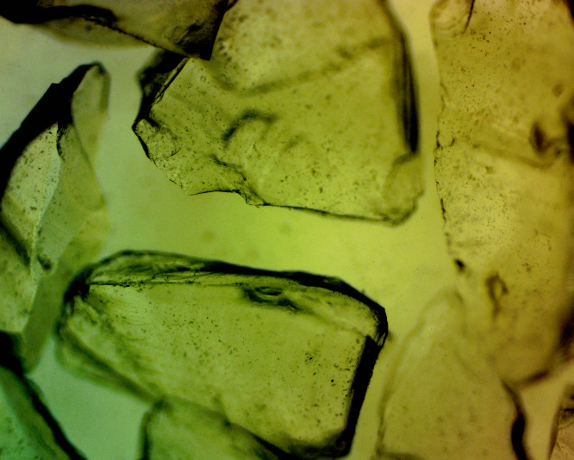 | 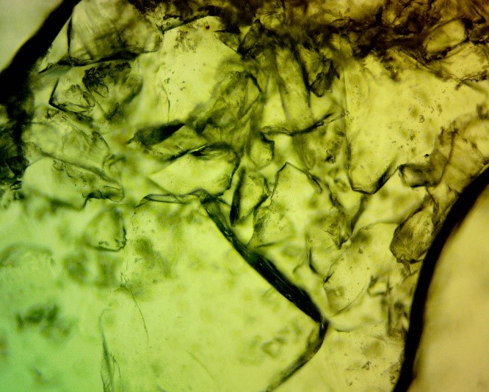

Figure 1. Particles of large (a) and small (b) fractions of crushed glass with partially rounded edges. The sections were observed under an optical microscope (OMAX 40X-2500X).

4.2. Hydroponic snd soil cultivation experiments

A preliminary hydroponic cultivation experiment was performed using bean seedlings to evaluate the potential influence of finely ground waste glass on plant development and to assess the possible adverse effects of glass particles on root growth.
Hydroponic cultivation was selected as an initial screening method because it enables direct observation of root development without the influence of soil variability. Bean seedlings were grown under water-based conditions with the addition of different concentrations of finely ground waste glass. Three experimental groups were established:

- control group (0% glass),
- 3% ground glass addition,
- 5% ground glass addition.

Each treatment consisted of five plant samples. Owing to the limited number of samples, the experiment was considered preliminary and intended to identify possible trends for further research rather than provide statistically definitive conclusions. After cultivation, shoot and root lengths were measured.
A parallel pot experiment was conducted to evaluate the effect of waste glass addition under various soil conditions. Bean seedlings were cultivated in a conventional soil substrate with two treatments:

- control soil without added glass (0%),
- soil containing 5% ground waste glass.

Five samples were used per treatment. After cultivation, the root and shoot lengths were measured and compared between the treatments.

5. PRELIMINARY RESULTS AND DISCUSSION

Mechanical processing produced fine glass particles with partially rounded edges (Figure 1). The absence of predominantly sharp edges indicated that the applied grinding procedure was suitable for obtaining a material that could be incorporated into plant-growing systems. This preliminary observation was important because sharp glass fragments may physically damage developing root systems. The results of hydroponic cultivation are summarized in Table 1.

Table 1. Results of hydroponic cultivation

 | Root lenght (cm) | Shoot lenght (cm)
Control | 22.2 | 11.8
Glass 3% | 22.7 | 5.5
Glass 5% | 19.56 | 9.62

The addition of ground glass did not cause visible inhibition of root development. Compared with those in the control treatment, the plants in the 3% glass treatment presented slightly longer roots, whereas those in the 5% glass treatment presented somewhat reduced average root length. However, owing to the limited number of samples, these differences cannot be considered statistically significant.
The most noticeable morphological difference was observed in the plants cultivated with 5% glass addition, which developed more pronounced lateral root formation than the control and 3% glass treatments did (Figure 2). Additionally, slightly darker coloration of leaves was observed, which could indicate changes in plant physiological responses; however, further biochemical analyses are needed to confirm possible mechanisms, such as phenolic compound accumulation or oxidative stress responses.

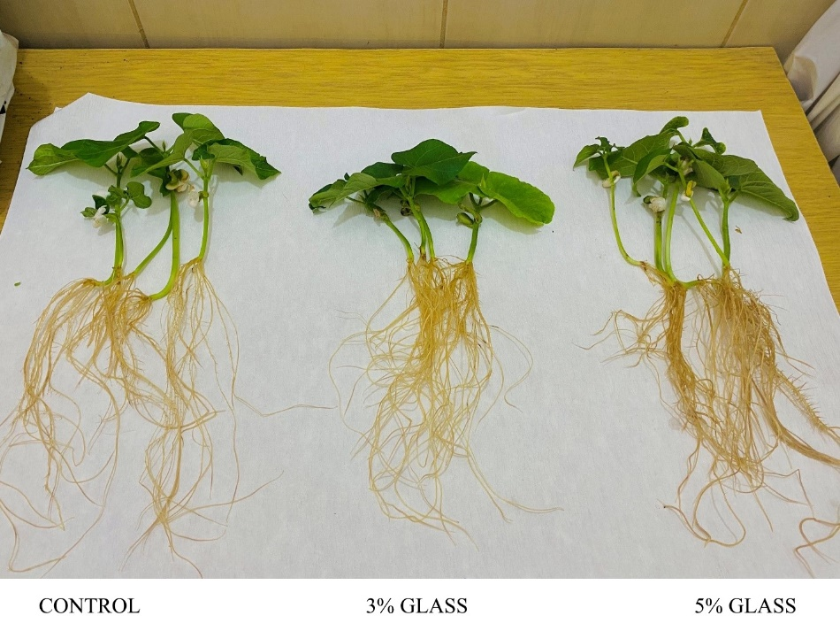
Figure 2. Morphological differences between plants cultivated with 3% and 5% glass and control plants.

The results obtained from the pot experiments are presented in Table 2.

Table 2. Results of soil cultivation

 | Root lenght (cm) | Shoot lenght (cm)
Control | 13.3 | 8.9
Glass 5% | 20.3 | 10.5

Compared with those in the control treatment, the plants in the soil containing 5% ground waste glass presented increased root and shoot development (Figure 3). The root length showed the most pronounced improvement, increasing from 13.3 cm in the control treatment to 20.3 cm in the glass-containing substrate.

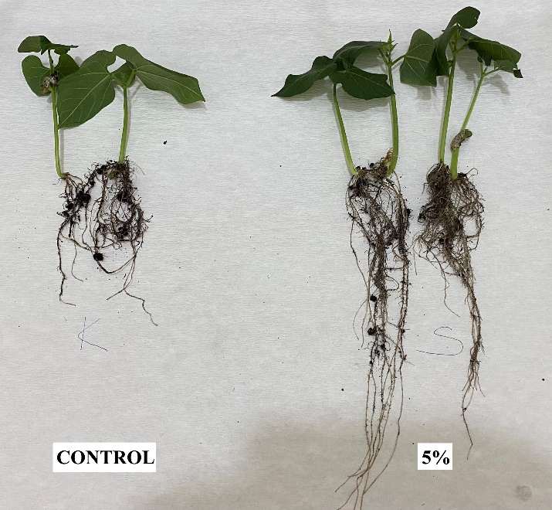
Figure 3. Morphological differences between control plant and plants cultivated in the soil containing 5% ground waste glass.

Although these differences suggest a potentially positive effect of waste glass incorporation, statistical significance could not be established because of the limited experimental replication. The observed improvement may be related to changes in substrate physical properties, including improved aeration and drainage, or potentially to the gradual contribution of silicon-containing compounds from the glass matrix.

6. DISCUSSION

The present pilot study demonstrated that the incorporation of finely milled waste glass into growing media did not adversely affect bean growth and, in some cases, promoted root development. The absence of visible root damage confirms that the applied milling procedure successfully reduced particle sharpness, making the material suitable for direct contact with plant roots. This finding is important because the potential mechanical injury caused by angular glass particles has been considered one of the principal limitations for the horticultural application of recycled glass.
The enhanced root growth observed in the soil treatment containing 5% waste glass is likely associated with improvements in the physical properties of the growing medium. Owing to its low water absorption and relatively high density, finely ground soda-lime glass can improve substrate aeration, drainage, and structural stability while reducing compaction, thereby creating more favorable conditions for root penetration and development. Similar improvements in plant growth resulting from the incorporation of recycled glass-based materials have been reported for foamed glass substrates and other glass-containing horticultural media, where enhanced substrate structure contributed to better root performance and can be used as substrate conditioner.

Besides improving the physical properties of the substrate, finely milled waste glass may also serve as a slow-release source of plant-available Si. Mechanical milling substantially increases the specific surface area and creates fresh reactive surfaces, promoting the gradual weathering of the amorphous Si network. Consequently, it is expected that Si slowly dissolves, releasing monosilicic acid (H₄SiO₄), the only form of Si that can be absorbed by plant roots. Although Si availability was not directly measured in the present study, this mechanism may partly explain the enhanced root development and the more pronounced lateral root formation observed in the 5% glass treatment.
The darker leaf coloration observed in plants grown with 5% glass under hydroponic conditions may also indicate improved physiological status. However, because no physiological or biochemical analyses were performed, these observations remain speculative and should be verified by determining chlorophyll content, photosynthetic performance, antioxidant enzyme activity, and Si accumulation in plant tissues.
Compared with previous studies, the present work differs in that it investigates untreated mechanically milled consumer waste glass rather than engineered glass fertilizers or foamed glass products. Most previous research has focused either on specially formulated controlled-release glass fertilizers or on porous glass-derived substrates. In contrast, the present results suggest that conventionally processed waste glass can function as both a structural substrate component and a potential secondary Si source, thereby simultaneously supporting plant growth and promoting waste valorization within the framework of the circular economy.
Nevertheless, the present study has several limitations. The relatively small number of biological replicates prevented statistical validation of the observed differences, and only one glass concentration was evaluated under soil conditions. Furthermore, no measurements of substrate physical properties, Si availability, nutrient uptake, or plant biochemical responses were conducted. Future studies should therefore include larger experimental populations, longer cultivation periods, comprehensive characterization of substrate properties, determination of soluble Si and Si accumulation in plant tissues, and detailed physiological analyses to elucidate the mechanisms responsible for the observed growth responses. Such investigations would provide stronger evidence for the feasibility of using recycled waste glass as a sustainable horticultural substrate component.

7. CONCLUSION

The preliminary results indicate that finely processed waste glass can be incorporated into plant-growing systems without causing visible negative effects on bean development. The observed improvements in root growth, particularly under soil conditions with 5% glass addition, suggest the potential benefits of waste glass as a partial growing medium component. However, owing to the limited sample size and absence of statistical validation, further experiments with increased replication, controlled particle size distribution, and additional measurements of substrate properties and Si availability are needed.

8. REFERENCES

[1] O. Bat-Erdene, A. Szegő, M. Gyöngyik, I. Mirmazloum, and I. Papp, “Effects of silicon in plants with particular reference to horticultural crops - Review article,” International Journal of Horticultural Science, vol. 27, pp. 95-105., Jul. 2021, doi: 10.31421/ijhs/27/2021/9096.
[2] B. Tubana, T. Babu, and L. Datnoff, “A Review of Silicon in Soils and Plants and Its Role in US Agriculture: History and Future Perspectives,” Soil Science, vol. 181, p. 1, Oct. 2016, doi: 10.1097/SS.0000000000000179.
[3] R. J. Haynes, “A contemporary overview of silicon availability in agricultural soils,” Journal of Plant Nutrition and Soil Science, vol. 177, no. 6, pp. 831–844, 2014, doi: 10.1002/jpln.201400202.
[4] A. Tamayo, R. de la Torre, O. Ruiz, P. Lozano, M. A. Mazo, and J. Rubio, “Application of a glass fertilizer in sustainable tomato plant crops,” Journal of the Science of Food and Agriculture, vol. 98, no. 12, pp. 4625–4633, 2018, doi: 10.1002/jsfa.8992.
[5] O. Adekomaya and T. Majozi, “Mitigating environmental impact of waste glass materials: review of the existing reclamation options and future outlook,” Environ Sci Pollut Res Int, vol. 28, no. 9, pp. 10488–10502, Mar. 2021, doi: 10.1007/s11356-020-12263-0.
[6] R. Tayade, A. Ghimire, W. Khan, L. Lay, J. Q. Attipoe, and Y. Kim, “Silicon as a Smart Fertilizer for Sustainability and Crop Improvement,” Biomolecules, vol. 12, no. 8, p. 1027, Jul. 2022, doi: 10.3390/biom12081027.
[7] D. Debona, F. A. Rodrigues, and L. E. Datnoff, “Silicon’s Role in Abiotic and Biotic Plant Stresses,” Annu Rev Phytopathol, vol. 55, pp. 85–107, Aug. 2017, doi: 10.1146/annurev-phyto-080516-035312.
[8] “Pilot study uses recycled glass to grow plants for salsa ingredients,” American Chemical Society. Accessed: Jul. 10, 2026. [Online]. Available: https://www.acs.org/pressroom/presspacs/2024/august/pilot-study-uses-recycled-glass-to-grow-plants-for-salsa-ingredients.html
[9] K. Takeoka, K. Fukushima, J. Itoh, and A. Mouri, “Utility of Foamed Waste Glass as a Culture Medium for Horticulture,” Horticultural Research (Japan), vol. 16, no. 3, pp. 273–278, 2017, doi: 10.2503/hrj.16.273.
[10] M. Eksi and D. Rowe, “Green roof substrates: Effect of recycled crushed porcelain and foamed glass on plant growth and water retention,” Urban Forestry & Urban Greening, vol. 20, pp. 81–88, Dec. 2016, doi: 10.1016/j.ufug.2016.08.008.
[11] “ClimaGuard 80/71 User Guide | PDF | Materials | Building Engineering,” Scribd. Accessed: Jul. 22, 2026. [Online]. Available: https://www.scribd.com/document/828096917/2022-ClimaGuard-Product-User-s-Guide
[12] J. Shelby, Introduction to Glass Science and Technology, vol. 35. 2005. doi: 10.1039/9781847551160-FP005.
[13] iTeh Inc, “EN 572-1:2012 - Glass in building - Basic soda lime silicate glass products - Part 1: Definitions and general physical and mechanical properties,” iTeh Standards. Accessed: Jul. 22, 2026. [Online]. Available: https://standards.iteh.ai/catalog/standards/cen/08fd701e-cdb8-4b80-b2c2-76338aac2dc9/en-572-1-2012

ЕВАЛУАЦИЈА ОТПАДНОГ СТАКЛА КАО ДЈЕЛИМИЧНЕ ЗАМЈЕНЕ ЗА СУПСТРАТ ЗА УЗГОЈ БИЉАКА: ПИЛОТ СТУДИЈА

Сажетак: Интензивна пољопривредна и хортикултурна пракса убрзале су исцрпљивање биљкама доступног силицијума из земљишта, што је подстакло потражњу за одрживим алтернативним супстратима и стратегијама за опоравак ресурса. Ова пилот студија истражује могућност примјене механички прерађеног отпадног стакла (натријум-калцијумово стакло) као дјелимичне замјене за конвенционалне супстрате за узгој. Отпадно стакло је дробљено и мљевено до финих честица са дјелимично заобљеним ивицама како би се спријечило оштећење коријена, те је евалуирано коришћењем сита од 630 µм. Прелиминарни огледи изведени су са садницама пасуља (Phaseolus vulgaris) кроз три хидропонска третмана (0, 3 и 5% мљевеног стакла) и паралелни експеримент у земљишту (0% и 5% мљевеног стакла). Резултати показују да увођење отпадног стакла не инхибира развој коријена. Хидропонски узгој са 5% стакла стимулисао је израженије формирање латералног коријена и тамнију обојеност листова. У земљишним условима, супстрат са 5% стакла је примјетно побољшао раст, повећавајући просјечну дужину коријена са 13,3 cm (контрола) на 20,3 cm. Ови прелиминарни налази указују на то да отпадно стакло може послужити као функционална структурна компонента супстрата, потенцијално побољшавајући аерацију, дренажу и постепено ослобађање силицијума, иако су потребна даља истраживања са већим бројем понављања ради статистичке потврде и праћења дугорочних биохемијских ефеката.
Кључне ријечи: Отпадно стакло, Циркуларна економија, Супстрат за узгој, Ђубрење силицијумом, Аерација супстрата, Phaseolus vulgaris.

