Comparative Evaluation of Hydrogel Density Measurement Methods
Đorđe Milošević¹, Marija Brankovic^{1,2}, Sreten Perić³, Radovan Radovanović⁴, Mihael Bučko³, Fatima Živić¹
¹Faculty of Engineering. University of Kragujevac, Sestre Janjic 6, 34000 Kragujevac, Serbia
²Institute for Information Technologies, University of Kragujevac, Liceja Kneževine Srbije 1A, 34000 Kragujevac, Serbia
³University of Defence, Veljka Lukića Kurjaka 33, Belgrade, Republic of Serbia
⁴Academy of Criminalistic and Police Studies of the Republic of Serbia, 11080 Belgrade-Zemun, Serbia

Abstract:
This study compared two methods for determining the volume and density of 3D printed gelatin-based hydrogel samples. Nine different samples were analyzed using sand displacement method and ImageJ software. In the first method, sample volume was calculated from the change in sand height. In the second method, volume was calculated from the projected area and measured sample height. The two methods gave different volume and density values, especially for samples with irregular shapes and variable heights. Sand entering the gaps between the printed lines may have affected the displacement measurements, while the ImageJ method assumed a uniform thickness across the sample. The significant differences in density values obtained using the two methods indicate that the choice of measurement technique can strongly influence the determined density of hydrogels. Therefore, further validation using multiple measurement approaches and comprehensive statistical analysis is needed to evaluate the accuracy and reliability of density determination.

Keywords: Gelatin-based hydrogel; 3D printing; Density; Measurement Technique; Sand Displacement; ImageJ

- Introduction

Hydrogels are widely used in tissue engineering as scaffolds that support cell adhesion and proliferation, as well as systems for drug delivery [1]. Their high-water content and three-dimensional structure make these materials suitable for a wide range of biomedical and sensing applications. They can be prepared from natural or synthetic polymers, or combinations of both, allowing their properties to be adjusted for specific uses [2]. Hydrogel structure can be changed by adjusting its chemical composition and preparation method. In this way, properties such as porosity, swelling, stability, biocompatibility, biodegradability, and mechanical strength can be adapted to the specific use [3]. Hydrogel printability is the ability of the material to form a stable and reproducible three-dimensional structure with the intended dimensions [4].
Measuring the physical properties of hydrogels are complex because they exhibit dynamic changes of properties over time, depending on the environment and external influences. Hydrogel properties are time-dependent, environment-dependent, and dynamically altered by swelling, degradation, ionic composition, pH, temperature, and mechanical loading, which makes accurate characterization challenging [5], [6]. Hydrogel properties are typically grouped into structural, physical, mechanical, chemical, thermal, transport, and biological properties. The basic properties of hydrogels include their microstructure and morphology (e.g., pore size, porosity, and mesh size), physical properties (e.g., density, water content, and swelling behavior), mechanical and viscoelastic properties, transport properties (e.g., permeability and diffusivity), degradation behavior (e.g., weight loss and degradation rate), and surface and chemical characteristics, all of which govern their performance in biomedical application [7].
This study compared two practical methods for determining the volume and density of printed gelatin hydrogel samples: sand displacement and image analysis using ImageJ. The aim was to determine the suitability of these methods for measuring density of 3D printed hydrogel scaffolds.

2. Physical properties of hydrogels

Hydrogels can have a heterogeneous structure, with polymer-rich regions, different crosslink densities and water-filled pores. Water is distributed throughout the polymer network, and its interaction with the polymer chains contributes to the overall structure of the hydrogel [8]. Hydrogel properties depend on the distribution of water, crosslinking density, pore structure, and internal organization [9].
Hydrogel density can be determined using several methods, including direct mass-to-volume measurements, Archimedes' principle with a chemically inert, non-swelling immersion liquid, pycnometry, and image-based volumetric methods such as optical microscopy, micro-computed tomography (micro-CT), or magnetic resonance imaging (MRI) [10], [11]. Archimedes' principle (buoyancy method) uses a chemically inert, non-swelling immersion liquid, such as silicone oil, paraffin oil, or another fluid that does not penetrate or react with the hydrogel. In image-based methods, volume is reconstructed from optical images, microscopy, micro-CT, MRI, or 3D scanning and combined with mass measurements to calculate density.
Density is commonly determined from the mass and volume of a hydrogel sample. Hydrogel volume can be measured using a sand displacement method, after which density is calculated [12]. For hydrogels with regular geometries, volume can be determined from measured dimensions, which may be obtained either by direct physical measurements or by image-based techniques [13]. The selection of a suitable volume measurement method is therefore important when hydrogel samples differ in shape or surface regularity. Measuring hydrogel density can be challenging because hydrogels have a high-water content and their volume can change during swelling. Since density depends on both mass and volume, differences in the swelling state can affect the measured values [14]. These characteristics make the selection of an appropriate volume measurement method particularly important for printed hydrogel samples.
In addition to density, the performance of 3D printed hydrogels as biological tissue scaffolds is strongly influenced by the hydrogel swelling properties [2]. Hydrogel swelling is the ability of the polymer network to take up and retain large quantities of water, resulting in an increase in both mass and volume. This behavior influences hydrogel cross-linking density, mechanical performance, and degradation behavior. Swelling is commonly quantified by determining the swelling ratio, which can be calculated according to:
SR = (W_{s} - W_{i}) / W_{i}
where W_{s} is the weight of the swollen hydrogel and W_{i} is the initial dry weight of the sample. Several experimental approaches are available for evaluating hydrogel swelling, including swelling ratio determination, gel fraction analysis, and weight-loss measurements [3].

3. Materials and Methods
3.1. Sand displacement method
Nine 3D printed gelatin hydrogel samples, denoted by S1–S9, were tested. All samples were prepared using the same formulation, but different printing conditions were used. The measurements were performed seven days after fabrication.
The mass of each sample was measured by an analytical balance (RADWAG AS 220.R2, Poland; readability 0.1 mg). The sample volume was measured using dry, fine sand, a small 40 cm³ graduated glass beaker, and a vernier caliper. First, 20 cm³of sand was placed in the empty beaker. The height from the bottom of the beaker to the sand surface was measured with the vernier caliper. The reference height was 16.58 mm. For each measurement, one sample was placed in the empty beaker. The same pre-measured amount of sand was then added around and over the sample. The final sand height was measured in the same way as the reference height. The measurement procedure is shown in Figure 1.
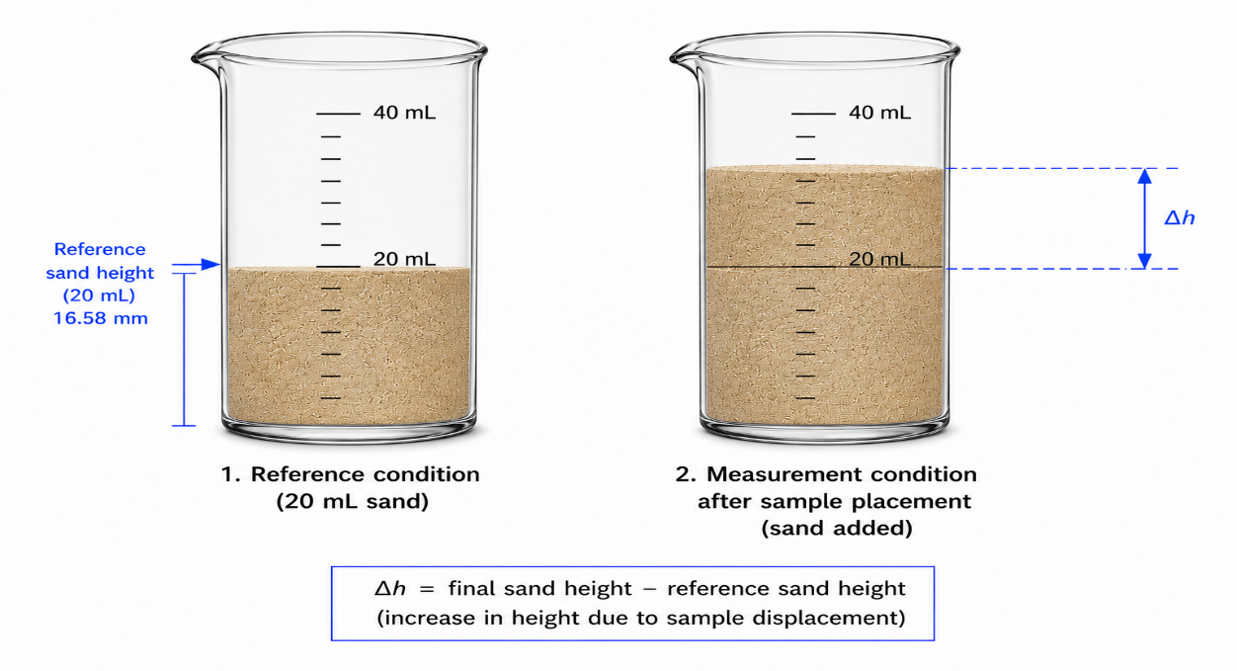
Figure 1. Sand-based volume measurement

The difference between the final height and the reference height was recorded as Δh. Since 20 cm³ of sand corresponded to a height of 16.58 mm, the sample volume was calculated from the measured height difference:
$$V_{s}\left(mL\right)=\frac{20}{16.58}∆h$$

where $V_{s}$ is the sample volume in millilitres and Δh is the measured height difference in millimetres.

The density of each sample was calculated by dividing its mass by the calculated volume:

$$ρ=\frac{m}{V_{s}}$$

where m is the sample mass in grams and $V_{s}$ is the sample volume in cm³. Density was expressed in g/cm³.
For sample S1, the density was calculated as 0.69 g / 2,87 cm³=0.24 g/cm³.

3.2 Image Analysis

Digital photographs of the samples were analyzed using the web version of ImageJ (ImageJ.JS) software. First, the photograph of each sample was opened in the software. A straight line was drawn along the previously measured length of the sample. This value was entered using the Set Scale option, and millimetres were selected as the unit. The sample was then manually outlined by marking its outside edges. After the complete sample was selected, the Measure option was used to calculate its area in mm². The height of each sample was measured using a Vernier caliper. The sample outline and area measurements in ImageJ are shown in Figure 2.
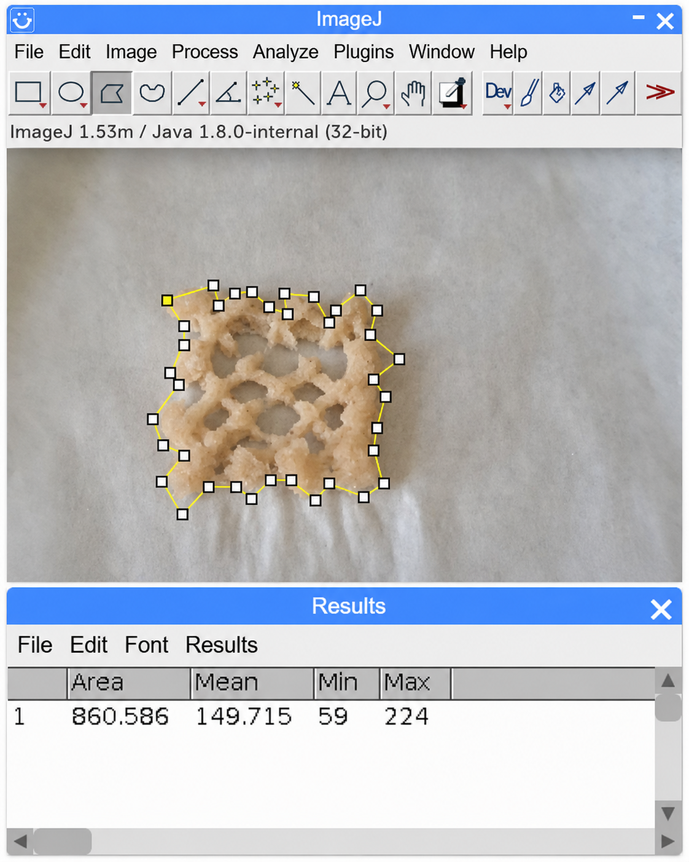
Figure 2. Area measurement of sample S2 in ImageJ software

The measured area and sample height were then used to calculate the volume:

$$V_{ImageJ}=A *h$$

where $V_{ImageJ}$ is calculated volume in $mm^{3}$, A is the projected area in mm², and h is the measured sample height in mm.

The volume was converted from cubic millimetres to cm³ using:

$$V_{ImageJ}\left(mL\right)=\frac{V_{ImageJ}\left(mm^{3}\right)}{1000}$$

The density was then calculated by dividing the sample mass by the calculated volume:

$$ρ=\frac{m}{V_{ImageJ(cm3)}}$$

where m is the sample mass and $V_{ImageJ}$is the calculated sample volumes in cm³.

4. Results and Discussion

The measured mass, height difference, calculated volume, and density of the hydrogel samples are presented in Table 1. The Sample column identifies each sample. Mass (g) shows the measured sample mass, while Δh (mm) represents the difference between the final and reference sand height. Volume (cm³) was calculated from Δh, and Density (g/cm³) was calculated by dividing the sample mass by the calculated volume.

Table 1. Measured mass and calculated volume using sand displacement method
Sample | Mass (g) | Δh (mm) | Volume (cm³) | Density (g/cm³)
S1 | 0.69 | 2.38 | 2.87 | 0.24
S2 | 2.25 | 4.20 | 5.07 | 0.44
S3 | 2.71 | 6.56 | 7.91 | 0.34
S4 | 0.74 | 2.04 | 2.46 | 0.30
S5 | 2.14 | 2.76 | 3.33 | 0.64
S6 | 3.24 | 2.16 | 2.61 | 1.24
S7 | 0.72 | 2.76 | 3.33 | 0.22
S8 | 2.43 | 3.18 | 3.84 | 0.63
S9 | 3.17 | 5.50 | 6.63 | 0.48

The density ranged from 0.22 to 1.24 g/cm³. Sample S7 had the lowest value, while S6 had the highest. Samples S5 and S7 had the same calculated volume of 3.33 cm³, but different masses, which led to different density values. The high density of S6 was due to its high mass and small volume. The sand could also enter the gaps between the printed lines and influence the volume measurement. A similar limitation has been reported for solid displacement measurements, where small particles entered open pores and caused errors in volume determination [15]. Table 2 presents the ImageJ measurements and the volume and density values for each sample. ImageJ software was used to measure the projected area (mm²). Mass (g) and Height (mm) show the measured sample mass and height. Calculated volume (cm³) was determined from the projected area and sample height, while Density (g/cm³) was calculated by dividing the sample mass by the volume.

Table 2. Volume and density obtained using ImageJ analysis
Sample | Projected area (mm²) | Mass (g) | Height (mm) | Calculated volume (cm³) | Density (g/cm³)
S1 | 547.10 | 0.69 | 5.90 | 3.23 | 0.21
S2 | 860.58 | 2.25 | 5.90 | 5.08 | 0.44
S3 | 1119.10 | 2.71 | 4.00 | 4.48 | 0.61
S4 | 688.10 | 0.74 | 6.00 | 4.13 | 0.18
S5 | 812.51 | 2.14 | 5.93 | 4.82 | 0.44
S6 | 797.93 | 3.24 | 6.20 | 4.95 | 0.65
S7 | 499.07 | 0.72 | 5.20 | 2.60 | 0.28
S8 | 708.24 | 2.43 | 6.10 | 4.32 | 0.56
S9 | 658.07 | 3.17 | 6.00 | 3.95 | 0.80

The volume values from the two methods were similar for S1, S2, S7, and S8, while larger differences were found for the other samples. The largest difference was found for S3, with a volume of 4.48 cm³ using ImageJ and 7.91 cm³ with the sand displacement method. The density values were also different. The smallest differences were found for S1 and S2, while the largest difference was found for S6. These differences may be caused by the irregular shape of the samples, different sample heights, and sand entering the gaps between the printed lines.
The two methods calculated sample volume differently. ImageJ used the projected area and measured height, while the sand method depended on how the sand settled around the sample. As a result, the calculated volume and density values were different. The ImageJ method used one image taken from above and one measured height for each sample. Since the samples had irregular shapes and were not equally thick in all areas, this may have affected the calculated volume. Measurements from images can also depend on the viewing angle, while images taken from different angles can describe the sample shape more accurately [16]. These factors may explain some of the differences in volume and density between the two methods.
The differences in density between the samples may also be related to their structure and the spaces between the printed lines. Previous research has shown that apparent density is related to hydrogel porosity, with a larger pore space generally associated with a lower apparent density [17]. Therefore, differences in the size and distribution of spaces within the tested samples may have contributed to the different density values.
The accuracy of volume measurements depends on the selected methodology and the characteristics of the hydrogel. Displacement methods using fine granular materials can better conform to irregular external geometries than simple two-dimensional image analysis. However, their resolution remains limited by particle size and packing behavior, and measurements may be affected by interactions between the granular medium and soft or hydrated hydrogel surfaces. Conversely, image-based methods are non-contact and can provide highly accurate volumetric measurements when combined with high-resolution three-dimensional imaging modalities such as micro-computed tomography, optical coherence tomography, or confocal microscopy. Furthermore, advanced computational image processing and artificial intelligence-based segmentation algorithms can improve surface reconstruction and volumetric accuracy by reducing image noise and enhancing boundary detection

5. Conclusion

This paper presented two methods for determining the volume and, subsequently, the density of 3D printed gelatin-based hydrogel samples: the sand displacement method and an image analysis method using ImageJ software to measure sample volume, combined with experimental mass measurements. These two methods yielded substantially different density values, highlighting the challenges in selecting the most suitable method for determining the basic physical properties of hydrogels, such as density.
The differences in density values were more pronounced for samples with irregular shapes and variable thicknesses resulting from the dimensional inaccuracies inherent in the 3D printing process. In the sand displacement method, sand may have entered the spaces between the printed strands, thereby affecting the measured volume. In the image analysis method, the sample volume was calculated using a single measured cross-sectional area and a single height value for each sample, which may not adequately represent samples with irregular geometries. These discrepancies in density values obtained using the two methods suggest that it would be beneficial to compare results from multiple measurement techniques and perform a more comprehensive statistical analysis to assess their accuracy and reliability.

Acknowledgments
This paper is supported through the EIT’s Higher Education Initiative A-SIDE project No. 24262, coordinated by EIT RawMaterials, funded by the European Union and supported by the projects No. 451-03-34/2026-03/200107 and No. 451-03-33/2026-03/200378, Ministry of Science, Technological Development and Innovation, Republic of Serbia

References:
[1] Baysal K, Aroguz AZ, Adiguzel Z, Baysal BM. Chitosan/alginate crosslinked hydrogels: Preparation, characterization and application for cell growth purposes. International Journal of Biological Macromolecules 2013;59:342–8. https://doi.org/10.1016/j.ijbiomac.2013.04.073.
[2] Priya AS, Premanand R, Ragupathi I, Bhaviripudi VR, Aepuru R, Kannan K, Shanmugaraj K. Comprehensive Review of Hydrogel Synthesis, Characterization, and Emerging Applications. J Compos Sci 2024;8:457. https://doi.org/10.3390/jcs8110457.
[3] Chai Q, Jiao Y, Yu X. Hydrogels for Biomedical Applications: Their Characteristics and the Mechanisms behind Them. Gels 2017;3:6. https://doi.org/10.3390/gels3010006.
[4] Naghieh S, Sarker M, Sharma NK, Barhoumi Z, Chen X. Printability of 3D Printed Hydrogel Scaffolds: Influence of Hydrogel Composition and Printing Parameters. Applied Sciences 2019;10:292. https://doi.org/10.3390/app10010292.
[5] Li X, Gong JP. Design principles for strong and tough hydrogels. Nat Rev Mater 2024;9:380–98. https://doi.org/10.1038/s41578-024-00672-3.
[6] Li J, Mooney DJ. Designing hydrogels for controlled drug delivery. Nat Rev Mater 2016;1:16071. https://doi.org/10.1038/natrevmats.2016.71.
[7] Liu B, Chen K. Advances in Hydrogel-Based Drug Delivery Systems. Gels 2024;10:262. https://doi.org/10.3390/gels10040262.
[8] Rosiak JM, Yoshii F. Hydrogels and their medical applications. Nuclear Instruments and Methods in Physics Research Section B: Beam Interactions with Materials and Atoms 1999;151:56–64. https://doi.org/10.1016/S0168-583X(99)00118-4.
[9] Raghuwanshi VS, Garnier G. Characterisation of hydrogels: Linking the nano to the microscale. Advances in Colloid and Interface Science 2019;274:102044. https://doi.org/10.1016/j.cis.2019.102044.
[10] Gibson LJ, Ashby MF. Cellular Solids: Structure and Properties. 2nd ed. Cambridge University Press; 1997. https://doi.org/10.1017/CBO9781139878326.
[11] Bouxsein ML, Boyd SK, Christiansen BA, Guldberg RE, Jepsen KJ, Müller R. Guidelines for assessment of bone microstructure in rodents using micro–computed tomography. Journal of Bone and Mineral Research 2010;25:1468–86. https://doi.org/10.1002/jbmr.141.
[12] Chavda H, Modhia I, Patel R, Patel C. Preparation and characterization of superporous hydrogel based on different polymers. Int J Pharma Investig 2012;2:134. https://doi.org/10.4103/2230-973X.104396.
[13] Fennell E, Huyghe JM. Chemically Responsive Hydrogel Deformation Mechanics: A Review. Molecules 2019;24:3521. https://doi.org/10.3390/molecules24193521.
[14] Richbourg NR, Wancura M, Gilchrist AE, Toubbeh S, Harley BAC, Cosgriff-Hernandez E, Peppas NA. Precise control of synthetic hydrogel network structure via linear, independent synthesis-swelling relationships. Sci Adv 2021;7:eabe3245. https://doi.org/10.1126/sciadv.abe3245.
[15] Joardder MUH, Kumar C, Brown RJ, Karim MA. A micro-level investigation of the solid displacement method for porosity determination of dried food. Journal of Food Engineering 2015;166:156–64. https://doi.org/10.1016/j.jfoodeng.2015.05.034.
[16] Bagheri GH, Bonadonna C, Manzella I, Vonlanthen P. On the characterization of size and shape of irregular particles. Powder Technology 2015;270:141–53. https://doi.org/10.1016/j.powtec.2014.10.015.
[17] Corona-Escalera AF, Tinajero-Díaz E, García-Reyes RA, Luna-Bárcenas G, Seyfoddin A, Padilla-de La Rosa JD, González-Ávila M, García-Carvajal ZY. Enzymatic Crosslinked Hydrogels of Gelatin and Poly (Vinyl Alcohol) Loaded with Probiotic Bacteria as Oral Delivery System. Pharmaceutics 2022;14:2759. https://doi.org/10.3390/pharmaceutics14122759.

