ARTIFICIAL INTELLIGENCE AND SENSOR THEORY IN ENVIRONMENTAL MONITORING
Ivan Stevovic¹, Mihailo Jovanovic², Jovana Jovanović³
¹ Innovation Centre of the Faculty of Mechanical Engineering, University of Belgrade, RS, istevovic@mas.bg.ac.rs
² Faculty of Management, Herceg Novi, University Adriatik, ME, mihajovanovic30@gmail.com
³ Faculty of Civil Engineering and Management, University Union Nikola Tesla, Belgrade, jjovanovic@unt.edu.rs

Abstract: Environmental monitoring increasingly depends on dense sensor networks, remote platforms and automated analytics capable of transforming heterogeneous measurements into timely knowledge for decision making. This paper examines how artificial intelligence and sensor theory can be integrated to improve the reliability, interpretability and usefulness of environmental monitoring systems. The central argument is that AI can enhance detection, prediction and response only when it is coupled with rigorous sensor theory, including calibration, uncertainty quantification, sampling design and validation against reference observations. The paper reviews applications in air, water, soil, climate and ecosystem monitoring, emphasizing Internet of Things architectures, machine learning, deep learning and remote sensing. It also discusses methodological requirements for data preprocessing, sensor fusion, model selection and uncertainty-aware inference. The results indicate that AI-enabled monitoring can increase spatial and temporal resolution, reduce operational costs and support proactive environmental management, but these benefits depend on transparent models, robust calibration, representative training data and governance frameworks that protect data quality and public trust. The paper concludes that sustainable environmental monitoring should be designed as an integrated socio-technical system in which sensors provide traceable measurements, AI provides adaptive interpretation, and human expertise ensures accountability and context-sensitive decisions.

Key words: Artificial Intelligence, Sensor Theory, Statistics, Environment, Sustainable Development.

- INTRODUCTION

Environmental monitoring is essential for protecting ecosystems, public health and long-term sustainable development because environmental risks are increasingly complex, spatially dispersed and time dependent. Traditional monitoring systems based on periodic sampling and laboratory analysis remain indispensable, but they often lack the temporal resolution needed to detect short pollution events, rapid hydrological changes or cumulative ecological stress. The expansion of low-cost sensors, wireless sensor networks, satellite observations and cloud computing has created new opportunities for continuous monitoring at multiple scales. Recent reviews show that smart environmental monitoring combines sensors, Internet of Things infrastructure and machine learning to track air quality, water quality, radiation, agriculture and other environmental variables in near real time [1].
Artificial intelligence is valuable in this context because environmental data are heterogeneous, noisy, nonlinear and strongly affected by local context. Machine learning models can identify patterns in high-dimensional time series, classify images, detect anomalies and forecast pollution or climate-related indicators. Deep learning has become especially important in remote sensing because convolutional and recurrent neural networks can extract spatial and temporal features from satellite, aerial and ground-based observations. A practical review of AI in remote sensing highlights applications in land-cover mapping, object detection, change detection, radar analysis and data fusion, while also stressing uncertainty and interpretability as major challenges [2].
However, AI alone cannot guarantee valid environmental knowledge. Sensor theory provides the principles by which measurements are generated, calibrated, filtered, interpreted and assigned uncertainty. Without attention to sensitivity, selectivity, drift, noise, resolution, detection limits and traceability, AI models may learn artefacts rather than environmental processes. Low-cost environmental sensors are particularly vulnerable to drift and cross-sensitivity, which can bias policy-relevant conclusions if calibration is weak. Statistical approaches to calibration uncertainty show that environmental sensor networks need explicit uncertainty modelling to remain useful in real deployments [3]. Figure 1 illustrates complex relation between environment, its monitoring and artificial intelligence models. Also figure 1 illustrates the concept of environment monitoring and consequently the image of observed (monitored) phenomenon relevant for decision making.

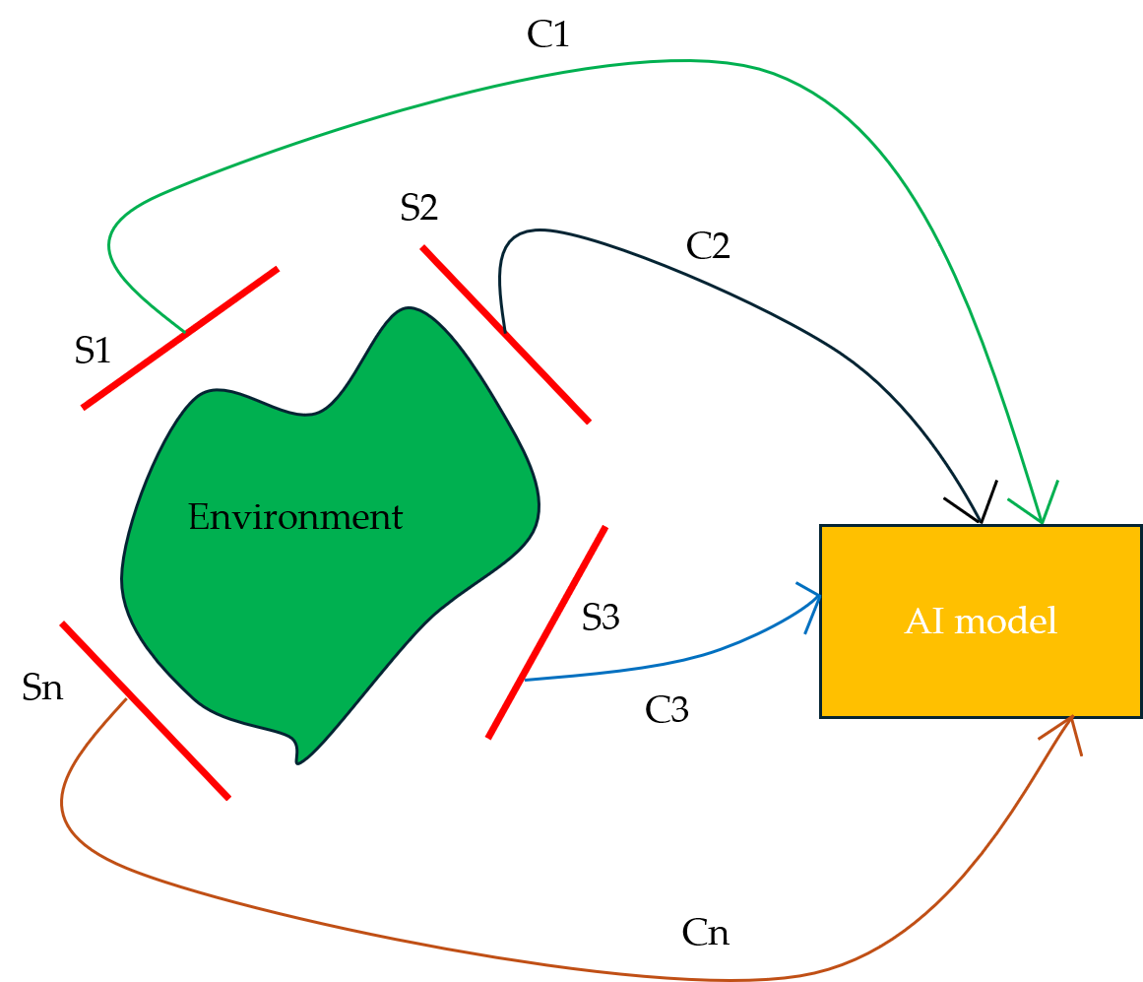

Figure 1. The concept of environment monitoring supported by AI

In the general mathematical form shown concept could be described as follows.:

$$I_{E}=Ψ\left(\sum{S_{i}};\sum{C_{i}};AI\right)$$

where:
- $I_{E}$ – representation (image) of environment formed on the base of sensors, channels of information flow and model of AI;
- $Ψ$ – function which transforms data to environment representation (“image” of environment);
- $\sum{S_{i}}$ – sensors applied;
- $\sum{C_{i}}$ – channels for information transportation from the sensor to the AI model and
- $AI$ – AI model applied.
Further analysis could be refined by introduction signal/noise analysis (both for the sensors and channels) and reliability of AI model applied.
In this paper, the mathematical description is used only as a compact methodological framework rather than as a full experimental model. Sensor behaviour is represented through measurement and calibration equations that relate the observed signal to the true environmental variable, contextual influences and random error, which follows recent work on calibration uncertainty and Bayesian calibration in environmental sensor networks [3], [4]. Sensor fusion is then described by weighted combinations of calibrated measurements, where more reliable sensors receive greater influence, consistent with weighted multisensor fusion theory [5]. Finally, the AI component is expressed as a supervised prediction model trained by minimizing a loss function such as mean squared error, linking machine learning performance directly to calibrated and uncertainty-qualified sensor data [6].

- MATERIALS AND METHOD

The paper applies a conceptual review method focused on the intersection between AI, sensor theory and environmental monitoring. The reviewed literature was selected to represent three connected domains: smart sensor systems and Internet of Things architectures, AI and machine learning methods for environmental interpretation, and metrological or statistical approaches to calibration and uncertainty. Priority was given to peer-reviewed review papers and methodological studies because the aim is to synthesize principles rather than report a single experiment. The material was organized around five analytical questions: what sensors measure, how sensor data quality is maintained, how AI models transform measurements into information, how uncertainty is represented, and how monitoring outputs support sustainable development decisions.
From the sensor-theory perspective, an environmental monitoring system begins with the relation between the target variable and the measurable signal. This relation may be physical, chemical, optical, acoustic or biological, and it is affected by environmental conditions such as temperature, humidity, pressure, turbidity or matrix composition. Calibration links the sensor output to a reference value, while validation tests whether the calibrated response remains stable outside laboratory conditions. Bayesian calibration has been proposed for multisensory systems in open environments because it can combine pollutant correlations, environmental covariates and model uncertainty [4].
From the AI perspective, the methodological pipeline includes data acquisition, quality control, preprocessing, feature engineering or representation learning, model training, evaluation and deployment. Typical preprocessing tasks include missing-value treatment, outlier detection, temporal alignment, spatial interpolation, normalization and correction for drift. Supervised learning is suitable when reference labels or laboratory measurements are available, unsupervised learning supports anomaly detection and clustering, and reinforcement learning may guide adaptive sampling or control. Recent work on AI and IoT for environmental pollution monitoring emphasizes that model choice must balance predictive performance, interpretability, data requirements and data-sharing constraints [7].
Sensor fusion is a key methodological bridge between sensor theory and AI. Environmental systems are rarely described adequately by one sensor type, so monitoring often integrates fixed stations, mobile sensors, drones, satellites, citizen observations and laboratory measurements. Fusion may occur at the data level, feature level or decision level, depending on whether raw signals, learned representations or model outputs are combined. Integrating AI agents with IoT devices has been identified as a promising direction for water-quality and climate-data monitoring because it enables real-time analytics, predictive modelling and automated decision support [8].
For methodological clarity, the reviewed sensor and AI approaches can be summarized by several compact mathematical models. The general measurement model relates the sensor output to the true environmental variable, contextual covariates and random measurement error, following the logic of calibration and uncertainty modelling in environmental sensor networks [3], [4].

$y(t)=f(x(t),c(t))+ε(t)$ (1)

In Equation (1):
y(t) is the measured signal,
x(t) is the target environmental variable,
c(t) represents contextual influences such as temperature or humidity, and
ε(t) is measurement noise.
In the locally linear case, the calibration relation may be written as:

$y(t)=f(x(t),c(t))+ε(t)$ (2)

Calibration estimates the coefficients α, β and γ by minimizing residual differences between the sensor output and reference measurements. The calibrated estimate is therefore represented as:

$x̂(t)=g(y(t),c(t);θ)$ (3)

Here, θ denotes calibration parameters learned from laboratory or field data. A simplified uncertainty decomposition can be expressed as:

$Var[x̂(t)]=σ_{sensor}^{2}+σ_{cal}^{2}+σ_{env}^{2}$ (4)

Equation (4) emphasizes that final monitoring values depend not only on electronic noise, but also on calibration error and environmental variability.
For multisensor monitoring, sensor fusion can be expressed as a weighted estimate, where more reliable sensors receive greater influence. This formulation is consistent with standard weighted fusion and inverse-variance weighting approaches used to combine uncertain measurements [5].

$ẑ(t)=\sum_{i}{w_{i}x_{i}(t)}, \sum_{i}{w_{i}}=1$ (5)

In Equation (5), $x_{i}(t)$ are calibrated estimates from individual sensors and wi are reliability weights. In uncertainty-aware fusion, sensors with lower variance can be assigned larger weights:

$w_{i}=\frac{(\frac{1}{σ_{i}^{2}})}{\sum_{j}{\frac{1}{σ_{j}^{2}}} }$ (6)

The AI component can be represented by a predictive model in which calibrated sensor readings, temporal variables, spatial descriptors and environmental covariates are used as inputs:

$ŷ=h(X;w)$ (7)

For supervised regression, the model parameters are estimated by minimizing a loss function such as the mean squared error, which is widely used to compare predicted and observed target values [6]:

$L(w)=\frac{1}{n} Σ(y_{i}-h(X_{i};w))²$ (8)

This formulation links sensor theory and AI because the quality of $h(X_{i};w)$ depends directly on calibrated, traceable and uncertainty-qualified input data.

- RESULTS AND DISCUSSION

The synthesis indicates that AI improves environmental monitoring most clearly when sensor readings are compared with reference measurements and then corrected through calibration or learning-based models. To illustrate this point, a numerical example was prepared for particulate matter monitoring in which a low-cost PM2.5 sensor was compared with a reference instrument over eight hourly observations (Table 1).
The raw sensor values were affected by a positive bias that may arise from humidity, particle composition or sensor drift, while the AI-corrected values represent the output of a simple trained correction model using the raw sensor signal and environmental covariates as inputs. This example is illustrative, but it follows the logic of calibration and uncertainty-aware monitoring described in the literature on environmental sensor networks [3]. Table 1 illustrates the implementation of corrections introduced by AI and absolute AI errors. It immediately follows that AI errors are significantly smaller than absolute raw errors.

Table 1. The obtained results within 8 hours (reference, measured, AI corrected, raw and AI errors)
Hour | Reference PM2.5 (µg/m³) | Raw sensor PM2.5 (µg/m³) | AI-corrected PM2.5 (µg/m³) | Absolute raw error | Absolute AI error
1 | 18 | 23 | 19 | 5 | 1
2 | 22 | 27 | 23 | 5 | 1
3 | 35 | 43 | 36 | 8 | 1
4 | 41 | 52 | 43 | 11 | 2
5 | 30 | 38 | 31 | 8 | 1
6 | 26 | 34 | 27 | 8 | 1
7 | 19 | 25 | 20 | 6 | 1
8 | 16 | 21 | 17 | 5 | 1

The numerical comparison shows that the raw sensor systematically overestimated PM2.5 concentrations. Across the eight observations, the mean reference concentration was 25.9 µg/m³, the mean raw sensor concentration was 32.9 µg/m³ and the mean AI-corrected concentration was 27.0 µg/m³. The mean absolute error decreased from 7.0 µg/m³ for the raw sensor to 1.1 µg/m³ after AI correction, which represents an error reduction of approximately 84.3%. The root means square error decreased from 7.3 µg/m³ to 1.2 µg/m³. These results demonstrate that AI can transform an inexpensive but biased sensor into a more reliable monitoring component when the model is trained and validated against reference data. Similar improvements are discussed in studies of AI and IoT pollution monitoring, where learning algorithms are used to correct nonlinear sensor responses and support real-time interpretation [7].
The example also shows why sensor theory remains necessary even when AI performance appears strong. The correction model reduces error, but it does not eliminate the need for calibration, uncertainty estimation or periodic verification. If the sensor is later deployed during another season, under different humidity conditions or near a different pollution source, the correction model may no longer represent the true relationship between the sensor signal and the pollutant concentration. Therefore, the corrected estimate should be reported together with uncertainty information, such as confidence intervals, calibration residuals or drift indicators. Bayesian calibration is useful in this setting because it can update estimates as new field measurements become available and can explicitly represent uncertainty in multisensor systems [8], [9].
The numerical example has practical implications for environmental decision making. Without correction, the raw sensor would classify several hours as more polluted than they actually were, potentially producing unnecessary warnings or distorted exposure estimates. After correction, the values are closer to the reference measurements and therefore more useful for public communication, operational response and long-term trend analysis.
Nevertheless, a monitoring system should not rely only on numerical error reduction. It should also evaluate sensor maintenance, data loss, communication latency, model drift and interpretability. This is particularly important in smart environmental monitoring networks where large numbers of distributed sensors are used to guide management actions [9], [10].
Illustrative block diagram of artificial intelligence and sensor theory implementation in environmental monitoring from very first moment of measurement to knowledge for sustainable environmental management is presented on Figure 2.

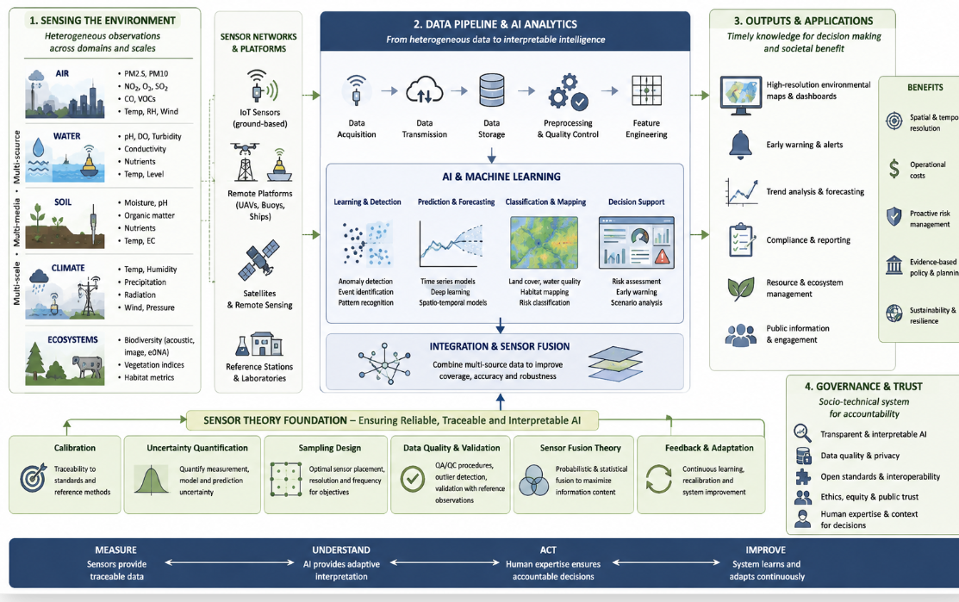
Figure 2. From measurement to knowledge for sustainable environmental management

Remote sensing broadens environmental monitoring beyond local stations. Satellites and airborne sensors provide repeated observations of vegetation, soil moisture, land-cover change, urban heat islands, floods, fires and coastal processes. AI improves the interpretation of remote-sensing data by automating feature extraction and classification, but the models must handle spectral variability, atmospheric effects, sensor differences and limited ground truth. A comprehensive review of remote sensing and AI emphasizes that future progress requires explainable models, multimodal learning and reliable deployment at global scale [11], [12].
The main limitation found in the reviewed literature is not the absence of algorithms, but the gap between algorithmic accuracy and measurement validity. Many models perform well under controlled or benchmark conditions but degrade when deployed in new locations, seasons or sensor configurations. This problem is intensified by environmental nonstationarity, where relationships among variables change over time. Uncertainty-aware calibration, validation against reference observations and transparent reporting are therefore essential. Real-time digital methods for sensor-output uncertainty are emerging because monitoring systems increasingly need to report not only a value, but also confidence in that value [13].
A second limitation is interpretability. Environmental agencies, municipalities and industrial operators often need to explain why an alert was issued, why a pollutant forecast changed or why one area was identified as high risk. Black-box models may be acceptable for exploratory analytics, but regulatory and public-health decisions require traceable reasoning. Explainable AI, physically informed learning and hybrid models can help connect statistical patterns with environmental mechanisms. Object-detection research using large environmental datasets demonstrates that domain-informed learning and uncertainty-aware predictions can improve robustness and interpretability in real-world monitoring [14].
The results also show that environmental monitoring should be evaluated as a socio-technical system. Technical performance indicators such as accuracy, precision, recall, latency, energy consumption and network reliability are necessary but insufficient. Monitoring systems must also be judged by maintainability, interoperability, cost, governance, cybersecurity and usefulness for stakeholders. Sustainable development requires that monitoring outputs support preventive action rather than merely document damage after it occurs. Smart environmental monitoring reviews therefore recommend robust machine learning, denoising methods, sensor-network standards and stronger links between technical design and environmental-management needs [15].
Further research should therefore focus on field validation of AI-corrected sensor networks under changing seasonal and site-specific conditions, development of standardized uncertainty-reporting procedures, comparison of interpretable and deep-learning models, and integration of low-cost sensors with satellite and laboratory reference data. Special attention should also be given to model drift, cybersecurity, data governance and the practical use of monitoring outputs by environmental agencies and local communities.

- CONCLUSION

Artificial intelligence and sensor theory are complementary foundations of modern environmental monitoring. Sensors convert environmental conditions into measurable signals, while AI transforms large and heterogeneous data streams into classifications, forecasts, maps and decision-support outputs. The paper shows that AI-enabled monitoring can improve temporal resolution, spatial coverage, early warning and operational efficiency, especially when combined with IoT architectures and remote sensing. At the same time, the quality of AI results depends on sensor calibration, uncertainty quantification, validation, data representativeness and interpretability. The most reliable monitoring systems will therefore be hybrid systems that combine traceable measurements, statistical sensor theory, domain knowledge and adaptive AI models. Future research should extend the field validation of AI-corrected sensor networks, standardize uncertainty reporting, compare interpretable and deep-learning approaches, integrate low-cost sensors with satellite and reference measurements, and address model drift, cybersecurity and governance so that monitoring outputs can be trusted by science, public authorities and local communities.

ACKNOWLEDGEMENTS

The results presented here are part of the research supported by the Ministry of Science, Technological Development and Innovation of the RS under Contract 451-03-33/2026-03/200213 dated 05.02.2026. year.

REFERENCES

- Ullo, S. L., and Sinha, G. R. (2020). Advances in Smart Environment Monitoring Systems Using IoT and Sensors. Sensors, 20(11), 3113. https://doi.org/10.3390/s20113113
- Janga, B., Asamani, G. P., Sun, Z., and Cristea, N. (2023). A Review of Practical AI for Remote Sensing in Earth Sciences. Remote Sensing, 15(16), 4112. https://doi.org/10.3390/rs15164112
- Smith, M. T., Ross, M., Ssematimba, J., Álvarez, M. A., Bainomugisha, E., and Wilkinson, R. (2023). Modelling calibration uncertainty in networks of environmental sensors. Journal of the Royal Statistical Society Series C: Applied Statistics, 72(5), 1187–1209. https://doi.org/10.1093/jrsssc/qlad075
- Dumon, M., Lebental, B., and Perrin, G. (2024). Optimizing Sensor Calibration in Open Environments: A Bayesian Approach for Non-Specific Multisensory Systems. SMAI Journal of Computational Mathematics, 10, 305–324. https://doi.org/10.5802/smai-jcm.114
- Liu, H., Fang, S., and Ji, J. (2020). An improved weighted fusion algorithm of multi-sensor. Journal of Physics: Conference Series, 1453, 012009. https://doi.org/10.1088/1742-6596/1453/1/012009
- Google Developers. (2026). Linear regression: Loss. Machine Learning Crash Course. https://developers.google.com/machine-learning/crash-course/linear-regression/loss
- Popescu, S. M., Mansoor, S., Wani, O. A., Kumar, S. S., Sharma, V., Sharma, A., Arya, V. M., Kirkham, M. B., Hou, D., Bolan, N., and Chung, Y. S. (2024). Artificial intelligence and IoT driven technologies for environmental pollution monitoring and management. Frontiers in Environmental Science, 12, 1336088. https://doi.org/10.3389/fenvs.2024.1336088
- Miller, T., Durlik, I., Kostecka, E., Kozlovska, P., Łobodzińska, A., Sokołowska, S., and Nowy, A. (2025). Integrating Artificial Intelligence Agents with the Internet of Things for Enhanced Environmental Monitoring: Applications in Water Quality and Climate Data. Electronics, 14(4), 696. https://doi.org/10.3390/electronics14040696
- Alshami, A., Ali, E., Elsayed, M., Eltoukhy, A. E., & Zayed, T. (2024). IoT innovations in sustainable water and wastewater management and water quality monitoring: A comprehensive review of advancements, implications, and future directions. IEEE Access, 12, 58427-58453.
- Yang, L., Ziwen, Z., Lin, X., Hei, J., Wang, Y., and Zhang, A. (2025). AI-powered approaches for enhancing remote sensing-based water contamination detection in ecological systems. Frontiers in Environmental Science, 13, 1612658. https://doi.org/10.3389/fenvs.2025.1612658
- Kazanskiy, N., Khabibullin, R., Nikonorov, A., and Khonina, S. (2025). A Comprehensive Review of Remote Sensing and Artificial Intelligence Integration: Advances, Applications, and Challenges. Sensors, 25(19), 5965. https://doi.org/10.3390/s25195965
- Katie, B. (2024). Internet of Things (IoT) for environmental monitoring. International Journal of Computing and Engineering, 6(3), 29-42.
- Lin, W., Li, T., and Li, X. (2025). Deep learning-based object detection for environmental monitoring using big data. Frontiers in Environmental Science, 13, 1566224. https://doi.org/10.3389/fenvs.2025.1566224
- Ficili, I., Giacobbe, M., Tricomi, G., & Puliafito, A. (2025). From sensors to data intelligence: Leveraging IoT, cloud, and edge computing with AI. Sensors, 25(6), 1763.
- Ramani, D. R., Sujitha, B. B., & Tangade, S. (2025). Smart environmental monitoring systems: IoT and sensor‐based advancements. Environmental Monitoring Using Artificial Intelligence, 45-60.

VEŠTAČKA INTELIGENCIJA I TEORIJA SENZORA U MONITORINGU ŽIVOTNE SREDINE

Apstrakt: Monitoring životne sredine sve više se oslanja na guste mreže senzora, udaljene platforme i automatizovanu analitiku sposobnu da heterogena merenja pretvori u pravovremene informacije za donošenje odluka. Ovaj rad razmatra kako se veštačka inteligencija i teorija senzora mogu integrisati radi unapređenja pouzdanosti, interpretabilnosti i korisnosti sistema za monitoring životne sredine. Osnovna teza rada jeste da veštačka inteligencija može unaprediti detekciju, predikciju i odgovor na promene u životnoj sredini, ali samo ukoliko je povezana sa rigoroznom primenom teorije senzora, uključujući kalibraciju, kvantifikaciju nesigurnosti, projektovanje uzorkovanja i validaciju u odnosu na referentna merenja. U radu su analizirane primene u monitoringu vazduha, voda, zemljišta, klime i ekosistema, sa posebnim osvrtom na arhitekture Interneta stvari, mašinsko učenje, duboko učenje i daljinsku detekciju. Takođe su razmotreni metodološki zahtevi koji se odnose na prethodno procesiranje podataka, fuziju senzorskih podataka, izbor modela i zaključivanje uz uvažavanje nesigurnosti. Rezultati ukazuju da sistemi monitoringa zasnovani na veštačkoj inteligenciji mogu povećati prostornu i vremensku rezoluciju, smanjiti operativne troškove i podržati proaktivno upravljanje životnom sredinom. Ostvarenje ovih prednosti zavisi od transparentnih modela, pouzdane kalibracije, reprezentativnih skupova podataka za obuku i odgovarajućih upravljačkih okvira koji obezbeđuju kvalitet podataka i poverenje javnosti. Zaključuje se da održivi monitoring životne sredine treba projektovati kao integrisani socio-tehnički sistem u kojem senzori obezbeđuju sledljiva merenja, veštačka inteligencija omogućava adaptivnu interpretaciju, a stručna ekspertiza čoveka garantuje odgovornost i donošenje odluka u skladu sa specifičnim kontekstom.

Ključne reči: veštačka inteligencija, teorija senzora, statistika, životna sredina, održivi razvoj.

