Thermophysiological comfort of clothing functionalized with Salvia rosmarinus essential oil and Phase Change Materials based on polyvinyl alcohol

Dragana Grujić¹, Branka Ružičić¹, Blanka Škipina^{1*}, Aleksandar Savić¹, Biljana Pećanin¹, Tanja Rauš¹, Saša Papuga¹, Stefano Vecchio Ciprioti², Dijana Jelić³
¹University of Banja Luka, Faculty of Technology,
Vojvode Stepe Stepanovića 73, 78000 Banja Luka, Bosnia and Herzegovina
²Sapienza University of Rome, Department of Basic and Applied Sciences for Engineering, Building RM017, Via del Castro Laurenziano 7, I-00161 Rome, Italy
³University of Banja Luka, Faculty of Natural Sciences and Mathematics,
Mladena Stojanovića 2, 78000 Banja Luka, Bosnia and Herzegovina
*Correspondence: blanka.skipina@tf.unibl.org (B.Š.)

Abstract This study investigates how the amount of polyvinyl alcohol (PVA), calcium chloride hexahydrate and di-sodium hydrogen phosphate heptahydrate, as phase change materials (PCMs), influenced the improvement of thermophysiological comfort in clothing. PCMs in the form of a paste with added Salvia rosmarinus essential oil (SREO) were applied to cotton knitted fabrics (Co) and T-shirts by screen-printing. Physiological parameters of the subjects (skin temperature and humidity), together with the amount of stored and released heat, confirmed that PVA in PCMs helped maintain body temperature within the comfort zone. MSR sensors showed that T-shirts printed with PCMs containing higher PVA concentrations stabilized skin temperature in the range of 33–34.5 °C and reduced skin humidity by 35%. In addition to thermoregulation, incorporation of SREO imparted antibacterial activity against Staphylococcus aureus and Escherichia coli. Such multifunctional textiles offer promising applications in sportswear and medical clothing, where both thermal comfort and antimicrobial properties are essential.
Keywords: polyvinyl alcohol; phase change materials; Salvia rosmarinus essential oil; thermophysiological comfort; antimicrobial textiles.

- Introduction

Phase change materials (PCMs) are designed to store and release thermal energy, thereby reducing temperature fluctuations. Their effectiveness depends on latent heat storage capacity, which governs the degree of thermal stabilization. For applications such as protective clothing, PCMs with higher energy storage potential are particularly valuable, as they enable more consistent regulation of body temperature under varying environmental conditions (Gao, 2014). One effective approach to enhancing the thermal comfort of textiles is the integration of PCMs, since their insulating properties remain unaffected by compression or moisture (Mäkinen & Jussila, 2014). Incorporating PCMs into a textile substrate can achieve multiple thermal effects, including cooling, heating, thermo-regulation, and active thermal barrier performance (Pause, 1999; Pause, 2001; Shishoo, 2002; Mondal, 2008; Sarier & Onder, 2007). Human thermal comfort is disturbed when body temperature deviates by approximately 4.5 $℃$ above or below the comfort threshold of 33.4 $℃$ (Demartino et al., 1984; Havenith et al, 2008).
According to Rossi (2014), the most effective approach for evaluating the cooling and heating performance of PCM clothing is direct testing on human subjects. Based on the chemical composition, PCMs can be classified into three categories: inorganic, organic, and eutectic PCMs. Inorganic PCMs are further divided into hydrated salts, metal alloy, and other inorganic compounds. Hydrated salts offer several advantages, including high latent heat, good thermal conductivity, low cost, and non-toxicity. However, many salt hydrates exhibit incongruent melting, which results in poor stability and pronounced supercooling (Li et al., 2022). Importantly, salt hydrates are regarded as the least expensive among all PCMs (Kosny et al., 2013; Hirschey et al., 2018). Kazemi et al. (2023) developed thermo-regulated cotton fabrics by incorporating an inorganic eutectic mixture of Na₂HPO₄·12H₂O and Na₂CO₃·10H₂O directly into the textile structure, achieving a significant improvement in thermal performance.
Polyvinyl alcohol (PVA) is a promising thermoreversible matrix for stabilizing the shape of inorganic PCMs. PVA is biocompatible and non-toxic, with excellent film-formation ability, biodegradability, favorable mechanical properties, optical transparency, and low cost. Li et al. (2024) developed PVA composites with borax and n-octadecane, while Karimineghlani et al. (2017) prepared PCMs using hydrates of inorganic salts. Li et al. (2024) reported that prepared PVA composites exhibited excellent shape stability, high thermal stability, and large phase change enthalpy. These composites also demonstrated significantly improved mechanical properties and outstanding thermal management performance at low temperatures.
Naturally occurring cotton fibers can absorb considerable amounts of moisture and body sweat and release them into the air, thereby ensuing comfort and ventilation. However, conventional cotton fabrics provide limited protection against excessive summer heat and cannot adequately regulate body temperature within the comfort range. To address this limitation, immobilization of encapsulated PCMs has been proposed to improve the thermoregulatory properties of cotton fabrics Sufficient porosity of the textile substrate enhances latent heat storage capacity, as it allows greater incorporation of encapsulated PCMs (Prajapati & Kandasubramanian, 2020). Screen-printing method facilitates higher water vapor transfer through the fabric, thereby improving breathability, while the coated fabric becomes softer and more flexible. An additional advantage of printing is the ability to control the coating area on textile surfaces. Nejman et al. (2014) applied PCMs to PET fabrics using printing, coating, and padding techniques and reported that printing process yielded the highest melting enthalpy of the PCM-incorporated fabrics, although with the lowest air permeability. A novel screen-printing approach was described by Lotenbach and Sutte (2002), in which PCM was applied in the form of naps containing high concentrations of microcapsules. Their findings demonstrated that the accumulation of PCM in naps largely preserved fabric elasticity as well as the substrate’s ability to exchange vapor and moisture.
In this study, we investigated how the percentage of PVA in PCMs influences the enhancement of the thermophysiological comfort of clothing. PCMs were prepared with varying amounts of PVA, CaCl₂·6H₂O, and Na₂HPO₄·12H₂O, which undergo phase transitions by storing and releasing heat under changing climatic conditions. Beyond thermal regulation, this research incorporates Salvia rosmarinus essential oil into PCMs to achieve dual functionality: heat storage and release through phase transition, combined with antimicrobial activity. Unlike previously published studies that primarily focused on either thermal regulation or antimicrobial modification of textiles, our work integrates both aspects into a single PCM system. This dual effect enhances the potential of PCMs, making them particularly valuable for protective and functional textiles that integrate thermal comfort with antimicrobial performance. The novelty of this approach lies in the systematic evaluation of PVA concentration as a stabilizing matrix and the introduction of essential oil into PCM formulations, offering a new pathway for multifunctional textile design.

- Materials and Methods

  - Materials and chemicals

For the research a single weave cotton knitted fabric (Co) with a surface mass of $121 g/m^{2}$ and a vertical density of 17 and a horizontal density of 17 was used. All the chemicals and reagents used were of analytical grade and used as received without any further purification: PVA, CaCl₂·6H₂O and Na₂HPO₄·12H₂O were purchased from Lach-Ner (Czech Republic), while Muller–Hinton agar was purchased from Liofilchem (Italy).

  - Methodology

PCMs based on PVA were prepared in the form of a paste and printed on Co and T-shirts. Changes in the state of aggregation of PCMs, due to storage and release of heat, were investigated in several stages. In addition to thermal properties, other material properties (air permeability, sorption and antibacterial properties) important for defining the thermophysiological properties of clothing were also investigated.
Preparation of PCMs based on PVA and screen-printing of cotton knitted fabrics. For the preparation of PCMs pastes for printing on Co and T-shirts, different components were used: CaCl₂·6H₂O, Na₂HPO₄·12H₂O, PVA in different percentages (5 and 15%), and 2.5% Salvia rosmarinus essential oil. The melting point of CaCl₂·6H₂O is lower than Na₂HPO₄·12H₂O, so the ratio of components CaCl₂·6H₂O and Na₂HPO₄·12H₂O was 4:6, for the phase change to take place near body temperature. PCMs in the form of a paste were applied to Co and T-shirts, using a screen-printing process. Printing of Co and T-shirts was performed at a speed of $0.2 m/s$ in two passes using a screen mesh with $10 threads/cm$.
Analysis of the thermal properties of knitted fabrics printed with PCMs. Testing of thermal properties is carried out according to standard GB/T 11 048-2008 (Standardization Administration of China, 2008), on the device for testing thermal resistance $R_{ct}$, Thermal Guarded Hot Plate YG606D (Fanyuan Instrument, China). Through the instrument panel of the testing device, the necessary data are entered, such as plate temperature $T_{m}$ ($℃$), time $t$ (s), sample thickness $d$ (mm) and air temperature $T_{a}$ ($℃$). Air-conditioned samples of textile materials, with dimensions of 250 mm x 250 mm, are placed on a test plate heated to 35 $℃$, which is located inside the air conditioning chamber. After that, the device, within the given time, calculated the thermal resistance $R_{ct}$ ($m^{2}K/W$), the thermal conductivity $K$ ($W/(m^{2}K)$), and the coefficient of thermal conductivity $λ$ ($W/(mK)$), through the following equations:

$R_{ct}=\frac{\left(T_{m}-T_{a}\right)∙A}{H-ΔH_{c}}-R_{ct0}$ (1)

$K = 1/R_{ct}$ (2)

$= \frac{d∙{10}^{-3}}{R_{ct}}$ (3)

where $A$ is area of the test plate ($m^{2}$), $H$ is heating power of the test plate ($W$), $∆H$ - heating power correction value ($W$), $R_{ct0}$ thermal resistance value of the empty (without sample) test plate ($m^{2}K/W$).
Analysis of the heat storage and release of PCMs materials using IR camera. The temperature changes of PCMs printed knitted fabrics placed on plates of different temperatures were analyzed using infrared (IR) thermography. IR thermography employs cameras capable of detecting radiation in the IR range of electromagnetic spectrum, producing images of the detected radiation known as thermograms. As the temperature of an object increases, the amount of emitted radiation also rises; therefore, IR thermography provides a reliable means of observing temperature differences (Usamentiaga et al., 2014). The IR camera (FLIR E6-XT, Teledyne FLIR, USA) was used owing to its infrared detector with 43.200 pixels (240 × 180) and extended temperature range from 20 $℃$ to 550 $℃$, making it suitable for recognizing subtle temperature differences. Images subsequently processed and analyzed using FLIR software, which supported image evaluation and extraction of relevant results. For the experiment, test samples were placed on a hot plate heated to temperatures 35 $℃$. The IR camera was used to record the sample immediately after placement and then at one-minute intervals for the following 10 minutes, enabling observation of the effect of PCM on temperature changes over time.
Analysis of the air permeability of knitted fabrics printed with PCMs. The air permeability of the knitted fabrics printed with PCMs was tested according to the ISO 9237 standard (International Organization for Standardization, 1995) on the Air Permeability tester for textile SL-F07 (Skyline Instruments, China). Before testing, the samples were pre-conditioned under standard conditions. On each sample, 20 measurements were made at different locations. From the measured values, the average value of the amount of leaked air (in $l/m^{2}s$) was calculated.
Testing of water absorption capacity of knitted fabrics printed with PCMs. The water absorption test was carried out according to the standard DIN 53923 (Deutsches Institut für Normung, 2022). The water absorption capacity ($W_{ac}$) is calculated from the obtained values, according to the following equation:

$W_{ac}=\frac{m_{w}-m_{d}}{m_{d}}∙100$ (4)

where $m_{w}$ and $m_{d}$ are the wet and dry sample masses (expressed in $g$).
Testing of the antibacterial effect of knitted fabrics printed with PCMs. The antibacterial effect of knitted fabrics printed with PCMs was tested using the agar diffusion method (International Organization for Standardization, 2004; Wiegand et al., 2015). Staphylococcus aureus and Escherichia coli bacterial cultures were used for testing. A detailed description of the testing procedure is given in the paper by Grujić et al. (2023).
Testing of the thermophysiological comfort of T-shirts. Three T-shirts were chosen for testing the thermophysiological properties: T-shirt without a print (Model 1: M-Co), T-shirt printed with PCMs with 5% PVA (Model 2: M-PVA-5), and the T-shirt printed with PCMs with 15% PVA (Model 3: M-PVA-15). Samples of cotton T-shirts are printed on the front part (in the chest area) and on the back part (in the shoulder area). Testing the thermophysiological comfort of T-shirts printed with PCMs through wear testing included the following phases: 15 minutes of running on a treadmill at a speed of $3.5 km/h$, 5 minutes of rest, and 15 minutes of running on a treadmill at a speed of $5 km/h$. The presentation of research on the thermophysiological properties of T-shirts printed with PCMs is given in Figure 1.

Figure 1. Presentation of the research on the thermophysiological properties of T-shirts printed with PCMs.

A Modular Signal Recorder (MSR) device manufactured by MSR Electronics GmbH and IR camera were used to monitor thermal changes during wear testing of cotton T-shirts printed with PCMs. Using the MSR device and associated sensors, changes in skin temperature ($T_{skin}$) and relative skin humidity ($H_{skin}$) of the subjects were measured during the wear testing. Sensors for measuring $T_{skin}$ and $H_{skin}$ were attached to the subject in the chest area and in the shoulder blade area on the back. IR camera was used to measure the temperature changes of T-shirts, which occurred during the wear testing, due to the storage and heat release of the PCMs. Due to its practicality and ease of handling, monitoring temperature changes using an IR camera is a quick and efficient way to observe temperature differences that are clearly visible when registering light in a certain color spectrum, from blue, which represents the lowest temperature, to red, which represents the highest temperature.
Determining the amount of sweat secreted and absorbed into clothing. The total amount of sweat secreted and evaporated is calculated from the difference in the body weight of the subjects and their clothing, before and after the test, as well as the amount of sweat absorbed by the clothing, according to the following equations (Grujić & Geršak, 2017):

$m_{ev} = m_{b1} - m_{b2}$ (5)
$m_{ex} =m_{ev}+\left(m_{c2} - m_{c1}\right)$ (6)

where $m_{ev}$ is the amount of sweat evaporated, while $m_{b1}$ and $m_{b2}$ are the body masses (in $g$) of a person without clothes before and after testing, respectively. $m_{ex}$ is the amount of sweat secreted, while $m_{c1}$ and $m_{c2}$ are the masses of clothes (in $g$) before and after testing, respectively.

- Results and discussion

  - Thermal properties of knitted fabrics printed with PCMs

The results of testing the thermal properties of Co printed with PCMs, at different temperatures of the heat plate, are presented in Table 1.

Table 1. Results of testing the thermal properties of Co printed with PCMs
Sample | Thickness  $d$ ($mm$) | Thermal  Resistance  $R_{ct}$($m^{2}K/W$) | Thermal  Conductivity Coefficient  $λ$ ($W/(mK)$) | Thermal  Conductivity  $K$ ($W/(m^{2}K)$)
Co | 0.36 | 0.0331 | 0.0109 | 30.21
Co-PVA-5 | 0.54 | 0.0300 | 0.0179 | 33.29
Co-PVA-15 | 0.55 | 0.0358 | 0.0154 | 27.96

From the results of testing the thermal properties of Co printed with PCMs, Table 1, it was evident that the thermal conductivity ($K$) or coefficient of thermal conductivity ($λ$) was the highest in knitted fabrics printed with 5% PVA (Co-PVA-5). With an increase in the concentration of PVA (15%) in PCMs, the thermal conductivity decreased, and the values for $K$ ($W/(m^{2}K)$) and $λ$($W/mK$) were lower than the values for the initial sample (Co). From the aspect of thermophysiological comfort of clothing and based on measurements of the thermal properties of Co printed with PCMs, Co printed with 5% PVA (Co-PVA-5) proved to be the most suitable for making clothing intended for warm conditions.
For most materials, thermal conductivity decreased slightly with increased temperature. Salaün (2019) stated that high thermal conductivity reduced temperature differences in the material during melting and crystallization, thereby facilitating heat transfer. The same author also emphasized that it was possible to increase conductivity by inserting fibers or metal matrices, graphite or urea, or by increasing the exchange surface area.

  - Air permeability and water absorption capacity of knitted fabrics printed with PCMs

The results of testing the air permeability ($q$) and water absorption capacity ($W_{ac}$) of Co printed with PCMs are presented in Table 2.

Table 2. Test results of air permeability and water absorption capacity of Co printed with PCMs.
Sample | Air permeability  $q$ ($I/(m^{2}s$) | Water absorption capacity  $W_{ac}$ (%)
Co | 718.20 | 277.57
Co-PVA-5(EU) | 660.31 | 243.91
Co-PVA-15(EU) | 545.11 | 231.21

The results of air permeability ($q$) and water absorption capacity ($W_{ac}$) tests are presented in Table 2. Both $q$ and $W_{ac}$ value decreased with increasing the PVA concentration in PCMs. Air permeability was a parameter used to obtain information about the raw material composition and structure of the fabric. Therefore, the reduction in air permeability of knitted fabrics printed with PCMs was a consequence of reduced porosity. The reduction in porosity occurred due to the penetration of the polymer paste between the threads in the knitted fabric, as well as between the fibers in the yarn. This reduction in porosity could result in a lower amount of sweat evaporated during the wear testing of T-shirts.

  - Antibacterial properties of knitted fabrics printed with PCMs

The results of testing the antibacterial properties of Co printed with PCMs on E. coli and S. aureus are presented in Table 3.

Table 3. Results of testing the antibacterial properties of Co printed with PCMs.

Sample | Microorganisms tested
Co | S. aureus (NA) | E. coli (NA)
Co | 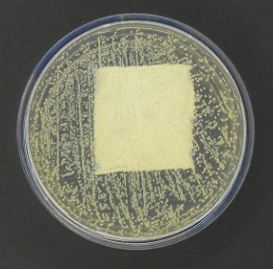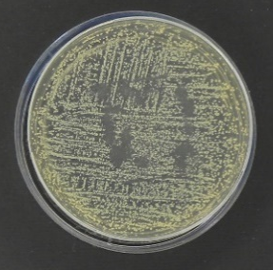 | 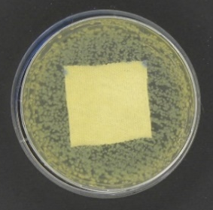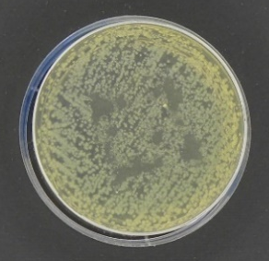
Co-PVA-5 | S. aureus (CI) | E. coli (PCI)
Co-PVA-5 | 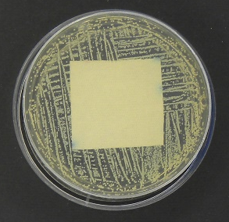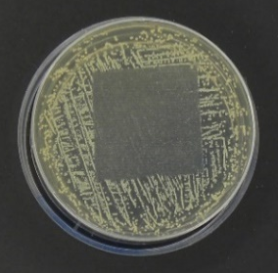 | 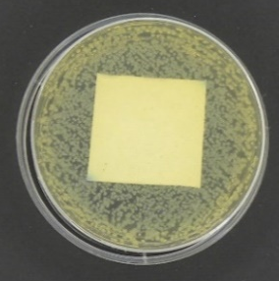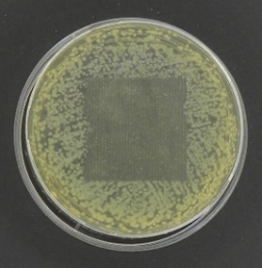
Co-PVA-15 | S. aureus (PCI) | E. coli (PCI)
Co-PVA-15 | 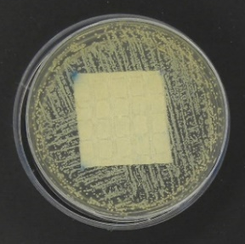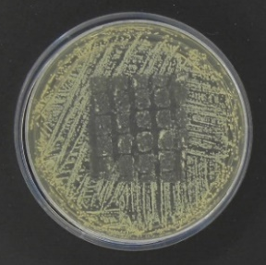 | 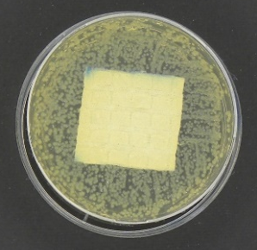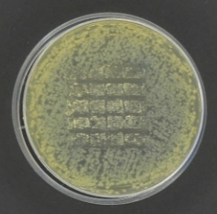
NA – no activity; CI – contact inhibition (the reduction of number of bacteria under the sample is 100%); PCI – partial contact inhibition (reduction of bacteria below the sample greater than 50%).
Based on the results of testing the antibacterial effect of Co fabrics printed with PCMs (Table 3), it was observed that Co-PVA-5 and Co-PVA-10 knitted fabrics exhibited a certain effect in the form of contact inhibition (CI) against E.coli and S.aureus. However, an increased concentration of PVA in PCMs weakened the antibacterial activity, so that the Co-PVA-15 knitted fabric was characterized by a partial contact inhibition (PCI).
The antibacterial properties of knitted fabrics originated from the essential oil of Salvia rosmarinus, which, in addition to PCMs, was incorporated into the printing paste. Houzi et al. (2025) reported that GC-MS analysis of the bioactive compounds in Salvia rosmarinus essential oil identified 16 compounds accounting for 99.19% of the total oil content, with 1,8-cineole (33.17%), camphor (16.53%), $α$-pinene (14.46%) and camphene (8.14%) as the main components. The dominant compound 1,8-cineole demonstrated a significant effect on S. aureus and E. coli. Numerous studies have demonstrated that bioactive components in extracts of medicinal plants, such as Achillea millefolium (Ivanović et al., 2022; Grujić et al., 2023; Gómez de Cedrón et al., 2024), Reynoutria japonica (Gorjanc et al., 2016; Suprun et al., 2024), Pinus sylvestris (Metsamuuronen et al., 2019; Ružičić et al., 2021; Česna et al., 2024), Picea omorika (Grujić et al., 2021), etc., exhibited strong antibacterial effects when applied to textile materials.

  - Results of analysis of heat storage and release of PCMs materials

Analysis of the heat storage and release of Co fabrics printed with PCMs, placed on a thermal plate heated to 35 $℃$, was performed by measuring the temperature of the samples with an IR camera. After setting the selected hot plate temperature on the device for determining thermal properties, IR camera measured the temperature of the hot plate ($T_{HP}$), the temperature of the sample immediately after placement ($T_{S}$), and then the temperature of the sample at one-minute intervals for the following 10 minutes. For analysis, the measured temperatures after 1 minute ($T_{S-1}$), 5 minutes ($T_{S-5}$), and 10 minutes ($T_{S-10}$) were selected (Table 4). Table 5 presents a graphical representation of the temperature measurement results of knitted fabrics printed with PCMs after the first, fifth, and tenth minutes, obtained by measuring with an IR camera.

Table 4. Temperatures of Co printed with PCMs measured with IR camera
Sample | $$T_{plate}$$  ($℃$) | Heating plate  $T_{HP}$ ($℃$) | After placing sample  $T_{S}$ ($℃$) | After  1 minute  $T_{S-1}$ ($℃$) | After  5 minutes  $T_{S-5}$ ($℃$) | After  10 minutes  $T_{S-10}$ ($℃$)
Co | 35 | 36.6 | 33.3 | 33.3 | 35.5 | 35.6
Co-PVA-5 | 35 | 36.6 | 34.8 | 35.2 | 36.0 | 36.1
Co-PVA-15 | 35 | 37.0 | 35.0 | 34.9 | 35.6 | 35.9

By analyzing the differences in the temperature of the knitted fabrics printed with PCMs after 1 min and after 10 min, obtained by measuring with IR camera, it was established that the smallest differences in temperature were measured in the sample with the highest PVA content (Co-PVA-15), Tables 4.
Temperature values ​​measured by IR camera over 10 minutes were lower for PCM-printed knitted fabrics containing a higher percentage of PVA. Therefore, it can be concluded that PCM-printed knitted fabrics with a higher percentage of PVA have a higher heat storage capacity, which is also confirmed by the measurement results for the Co-PVA-15 sample.

  - Results of analysis of thermophysiological properties of T-shirts printed with PCMs

Skin temperature and relative humidity measured with an MSR device. The thermophysiological properties of T-shirts printed with PCMs were tested by wearing them during various physical activities. The role of PCMs was assessed by measuring the skin temperature ($T_{skin}$) and the relative skin humidity ($H_{skin}$), using an MSR measuring device, with sensors placed in the chest area and on the back in the shoulder blade area. The results of skin temperature measurements during T-shirt wear testing and the relative humidity of the skin were presented in Figure 2 and 3, respectively.

Figure 2. Results of the skin temperature measurement in the chest area: (front side) (a) and in the shoulder blades area (back side) (b)

Figure 3. Results of the relative humidity measurement of the skin in the chest area: (front side) (a) and in the shoulder blades area (back side) (b)

The results of the skin temperature ($T_{skin}$) test of the subjects, Figures 2a) and 2b), obtained with the MSR device and associated sensors, indicated that $T_{skin}$ ranged from $33 ℃$ to $34.5 ℃$ (comfort zone), when the subject worn Model 3 (PVA15).
Grujić and Geršak (2017) stated that a more pronounced feeling of discomfort occurred when larger amounts of sweat secreted increased the degree of skin humidity, which led to a higher percentage of skin coverage with sweat. The relative skin humidity ($H_{skin}$) was lowest when the subject wore Model 3 (65%), Figures 3a and 3b, indicating that PCMs with 15% PVA reduced relative skin humidity and thereby contributed to improved thermophysiological comfort of the clothing.
Amount of sweat secreted and absorbed into the shirt. Based on the measured weights of the subjects and T-shirts before and after the wear testing, the amounts of sweat secreted by the subjects and absorbed by the T-shirts were calculated. The amounts of sweat secreted, evaporated and absorbed, calculated according to equations (5) and (6), for all three T-shirt models, are presented in Table 5.

Table 5. The amount of sweat secreted, evaporated and absorbed.
 | Model 1  (Cotton) | Model 2  (5% PVA) | Model 3  (15% PVA)
Amount of sweat evaporated (g) | 430.00 | 220.00 | 150.00
Amount of sweat secreted (g) | 431.64 | 222.77 | 152.95
Amount of sweat absorbed in a T-shirt (g) | 1.64 | 2.77 | 2.95

The highest amount of sweat ($431.64 g$) was measured when the subject was wearing Model 1 (cotton T-shirt without print), while the lowest ($152.95 g$) was recorded for Model 3 (cotton T-shirt with 15% PVA) (Table 5). During increased physical activity, one of the mechanisms of body temperature regulation was the increased secretion of sweat glands, maintaining thermal equilibrium. The reduced amount of sweat secreted in T-shirts printed with PCMs, 35% lower in Model 3 compared to the cotton T-shirt without print, demonstrated that the PVA content in PCMs had a significant impact on the thermoregulation of the human body.
Our results were consistent with previous findings reported in the literature. Grujić et al. (2010) indicated a statistically reliable relationship between the amount of sweat absorbed by clothing and the surface area and water retention capacity of fabrics of different raw material compositions, particularly at higher air temperatures and low wind speeds. Furthermore, other studies emphasized that the amount of sweat absorbed by clothing was significantly influenced by garment construction and ventilation (Grujić et al., 2014; Smith et al., 2019). In line with these observations, our investigation confirmed that the incorporation of PCMs with higher PVA content reduced sweat secretion and absorption, thereby contributing to improved thermoregulation.
T-shirt temperatures measured with an IR camera. IR camera was used to analyze the storage and release of heat in T-shirts printed with PCMs. The resulting images were processed in the Flir program and presented in Tables 6–8. During images processing, the maximum, the minimum and average temperatures were measured before, during rest, and after wear testing, on both the front and back of the T-shirt.
The maximum temperature on the measuring scale was set to $40 ℃$ and the minimum to $28 ℃$. The analyzed surfaces are marked with squares: the smaller square represented the position of the MSR sensor (Bx1), while the larger square represented the processed surface of the T-shirt (Bx2). Labels were attached to the front and back of the T-shirt.

Table 6. Results of measuring body temperature with an IR camera for Model 1 (Cotton).
MODEL 1 (Co)
Model 1 (before wear testing) |  |  |  | 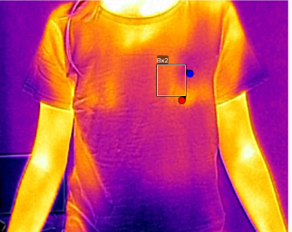  Front side | 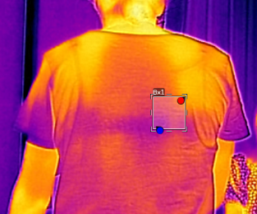  Back side
 | T_{max} ($℃$) | T_{min} ($℃$) | T_{average} ($℃$)
Bx1 front | 32.7 | 30.3 | 31.4
Bx1 back | 34.2 | 30.9 | 32.1
Model 1 (during rest) |  |  |  | 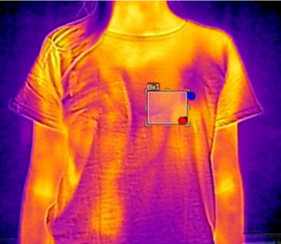  Front side | 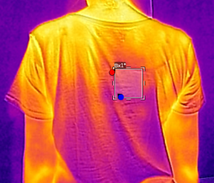  Back side
 | T_{max} ($℃$) | T_{min} ($℃$) | T_{average} ($℃$)
Bx1 front | 32.7 | 30.6 | 31.7
Bx1 back | 33.7 | 32.3 | 32.8
Model 1 (after wear testing) |  |  |  | 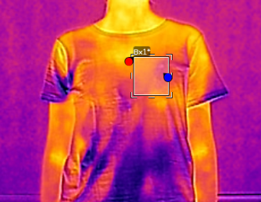  Front side | 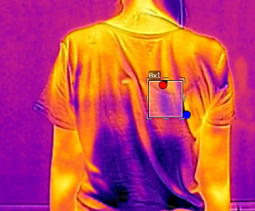  Back side
 | T_{max} ($℃$) | T_{min} ($℃$) | T_{average} ($℃$)
Bx1 front | 34.3 | 31.3 | 32.2
Bx1 back | 33.3 | 30.6 | 31.7

Table 7. Results of measuring body temperature with an IR camera for Model 2 (PVA-5).
MODEL 2 (PVA-5)
Model 2 (before wear testing) |  |  |  | 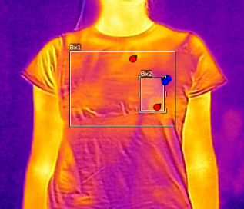  Front side | 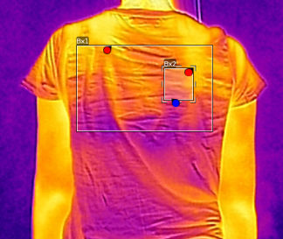  Back side
 | T_{max} ($℃$) | T_{min} ($℃$) | T_{average} ($℃$)
Bx1 front | 35.3 | 32.4 | 33.4
Bx2 front | 34.1 | 32.5 | 33.3
Bx1 back | 36.0 | 32.0 | 34.0
Bx2 back | 33.5 | 33.3 | 33.4
Model 2 (during rest) |  |  |  | 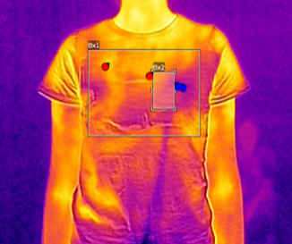  Front side | 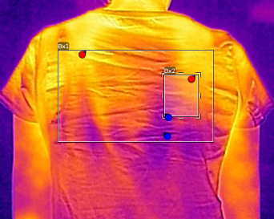  Back side
 | T_{max} ($℃$) | T_{min} ($℃$) | T_{average} ($℃$)
Bx1 front | 35.3 | 31.7 | 33.5
Bx2 front | 34.2 | 32.1 | 33.1
Bx1 back | 36.4 | 32.1 | 34.2
Bx2 back | 33.9 | 32.6 | 33.2
Model 2 (after wear testing) |  |  |  | 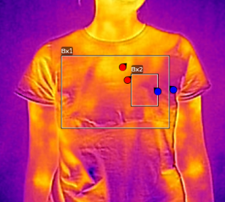  Front side | 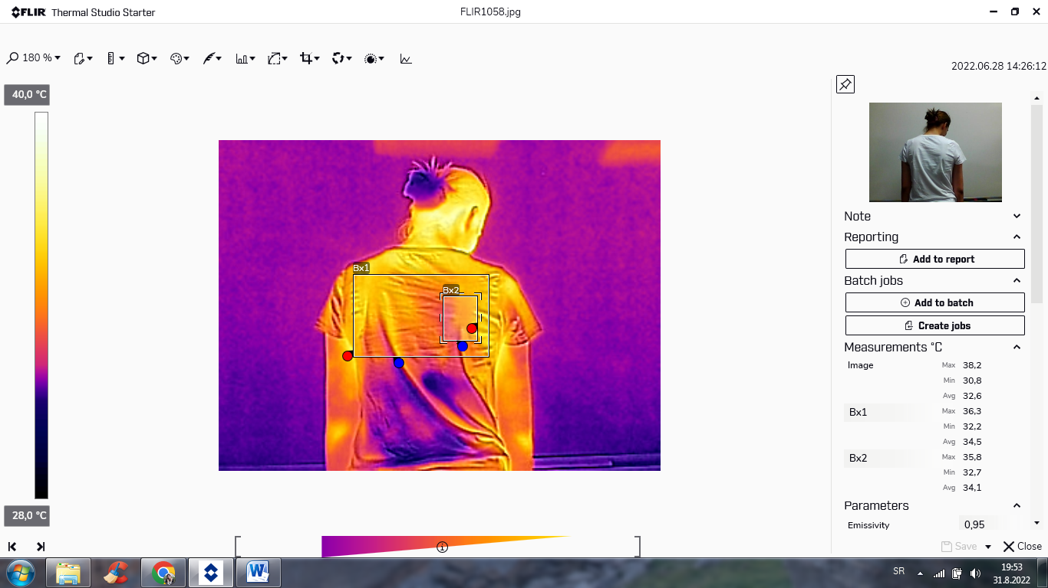  Back side
 | T_{max} ($℃$) | T_{min} ($℃$) | T_{average} ($℃$)
Bx1 front | 34.6 | 30.5 | 32.2
Bx2 front | 32.7 | 31.0 | 31.7
Bx1 back | 36.3 | 32.2 | 34.5
Bx2 back | 35.8 | 32.7 | 34.1

Table 8. Results of measuring body temperature with an IR camera for Model 3 (PVA-15).
MODEL 3 (PVA-15)
Model 3 (before wear testing) |  |  |  | 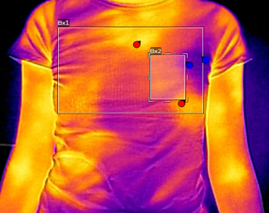  Front side | 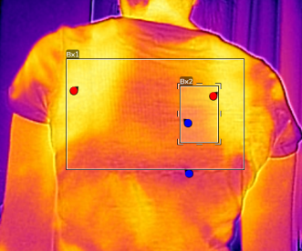  Back side
 | T_{max} ($℃$) | T_{min} ($℃$) | T_{average} ($℃$)
Bx1 front | 36.7 | 32.9 | 34.8
Bx2 front | 36.3 | 33.8 | 34.6
Bx1 back | 35.1 | 29.2 | 32.4
Bx2 back | 33.5 | 30.6 | 32.2
Model 3 (during rest) |  |  |  | 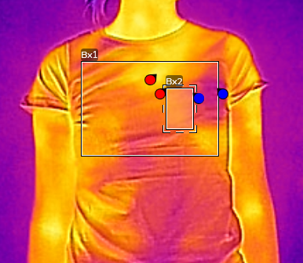  Front side | 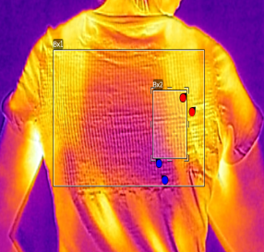  Back side
 | T_{max} ($℃$) | T_{min} ($℃$) | T_{average} ($℃$)
Bx1 front | 35.9 | 30.9 | 33.1
Bx2 front | 32.8 | 32.1 | 32.8
Bx1 back | 37.9 | 34.4 | 36.1
Bx2 back | 37.5 | 34.6 | 36.2
Model 3 (after wear testing) |  |  |  | 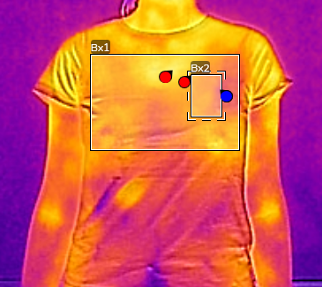  Front side | 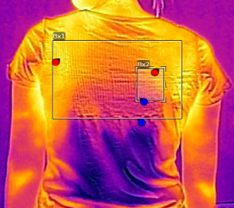  Back side
 | T_{max} ($℃$) | T_{min} ($℃$) | T_{average} ($℃$)
Bx1 front | 37.6 | 33.2 | 34.7
Bx2 front | 35.1 | 33.2 | 34.3
Bx1 back | 36.3 | 32.2 | 34.2
Bx2 back | 35.1 | 32.5 | 33.9

The storage and release of heat were controlled using the IR camera, whereby the subject's body temperature was measured before the start of running on the treadmill, during the rest phase, and after the end of the running. The results of measuring the physiological parameters of the test subjects ($T_{skin}$ and $H_{skin}$), as well as the amount of stored and released heat measured with the IR camera during wear testing of T-shirts, regardless of the intensity of physical activity, indicated that PCMs with 15% PVA maintained body temperature within the comfort zone. It is well known that the most comfortable skin temperature is $33.4 ℃$. Within $±3.0 ℃$ of this ideal temperature, humans do not perceive environmental difference, whereas discomfort occurs when the temperature changes by more than $4.5 °C$ (Peng et al., 2019). The positive impact of PCMs was reflected in the reduction of the $H_{skin}$ values of the respondents compared to the $H_{skin}$ measured when wearing the T-shirt without print ($H_{skin}$ was 100%). It should also be emphasized that the prepared PCMs released a characteristic, pleasant smell of rosemary essential oil from the T-shirt due to the greater heating of the subjects. Finally, it was concluded that PCMs, with their ability to undergo phase transition and thereby store or release heat, fulfilled their purpose of maintaining human body temperature during testing within the scope of this work.

- Conclusions

The investigation of the influence of poly(vinyl alcohol) (PVA) content in phase change materials (PCMs), applied to cotton knitted fabrics, was conducted by measuring air permeability, thermal behavior, sorption capacity, and antibacterial properties. The thermophysiological comfort of cotton T-shirts printed with PCMs was further evaluated through wear testing, monitoring skin temperature, relative skin humidity, and the amount of secreted, evaporated, and absorbed sweat.
The antibacterial activity of knitted fabrics printed with PCMs and Salvia rosmarinus essential oil on S. aureus and E. coli bacteria decreased with increasing PVA concentration in PCMs. Also, the lowest values ​​of air permeability and water absorption capacity were measured in samples printed with PCMs with the highest PVA content.
Thermal properties measurements using a heating plate at different temperatures indicated that increasing PVA concentration in PCM results in higher thermal resistance ($R_{ct}$) and lower thermal conductivity coefficient ($λ$). Parallel IR camera measurements confirmed that the smallest temperature differences were observed in the sample with the highest proportion of PVA.
Physiological parameters of the subject, obtained by measuring with the MSR device and associated sensors, indicated that the skin temperature ($T_{skin}$) ranged from $33 ℃$to $34.5 ℃$, while relative skin humidity ($H_{skin}$) was the lowest when the subject wearing Model3 (PVA15). This demonstrates that cotton T-shirts printed with PCM containing 15% PVA tend to maintain Tskin within ​​the comfort zone and reduce $H_{skin}$, thereby enabling better control of the thermophysiological comfort of the clothing.

- References

Česna, V., Česniene, I., Sirgedaite-Šežiene, V. & Marčiulyniene, D. (2024). Changes in biologically active compounds in Pinus sylvestris needles after Lymantria monacha outbreaks and treatment with Foray 76B. Plants 13, 328. https://doi.org/10.3390/plants13020328
Demartino, R.N., Yoon, H.N., Buckley, A., Evins, C.V., Averell, R.B., Jackson, W.W.,… Hollies, N.R.S. (1984). Improved comfort polyester. Part III: Wearer trials. Textile Research Journal, 54(7), 447–458. https://doi.org/10.1177/004051758405400707
DIN (2022). Testing of textiles—Determination of water absorption of textile fabrics (DIN 53923:2022-07). Deutsches Institut für Normung.
Gao, C (2014) Phase-change materials (PCMs) for warming or cooling in protective clothing. In F. Wang & C. Gao (Eds.), Protective clothing: managing thermal stress (pp 227–249). Woodhead Publishing. https://doi.org/10.1533/9781782420408.2.227
Gómez de Cedrón, M., Siles-Sánchez, M.d.N., Martín-Hernández, D., Jaime, L., Santoyo, S. & Ramírez de Molina, A. (2024). Novel bioactive extract from yarrow obtained by the supercritical antisolvent-assisted technique inhibits lipid metabolism in colorectal cancer. Frontiers in Bioengineering and Biotechnology, 12, 1256190. https://doi.org/10.3389/fbioe.2024.1256190
Gorjanc, M., Savić, A., Topalić-Trivunović, Lj., Možetič, M., Zaplotnik, R., Vesel, A. & Grujić, D. (2016). Dyeing of plasma treated cotton and bamboo rayon with Fallopia japonica extract. Cellulose,23, 2221–2228. https://doi.org/10.1007/s10570-016-0951-9
Grujić, D. & Geršak, J. (2017). Examination of the relationships between subjective clothing comfort assessment and physiological parameters with wear trials. Textile Research Journal, 87(12), 1522–1537. https://doi.org/10.1177/0040517516657054
Grujić, D., Geršak, J. & Ristić, M. (2010). Effect of physical and sorption properties of the fabric on the amount of the absorbed sweat on the garment. Tekstil 59(3), 68 –79.
Grujić, D., Janjić, S., Celcar, D., Jokanović, D. & Jevšnik, S. (2014). Impact of fibre composition and sports T-shirt ventilation on thermal comfort. Tekstilec 57(3), 220 –230. https://doi.org/10.14502/Tekstilec2014.57.220-230
Grujić, D., Savić, A., Topalić-Trivunović, Lj., Bizjak, M., Velemir, A. & Milanović, J. (2023). Ultrasonic-assisted antimicrobial functionalization of cotton knitwear with plant extracts. Journal of the Textile Institute, 114(8), 1206–1217. https://doi.org/10.1080/00405000.2022.2114287
Grujić, D., Škipina, B., Cerović, D., Topalić-Trivunović, Lj., Savić, A. (2021). Antibacterial and dielectric properties of textile materials modified with herbal extracts of Picea omorika and the copper ferrite nanoparticles. Contemporary Materials, 12(1), 80–90. https://doi.org/10.7251/COMEN2101080G
Havenith, G., Smith, C.J. & Fukazawa, T. (2008) The skin interface-meeting point of physiology and clothing science. Journal of Fiber Bioengineering and Informatics, 1(2), 93–98. https://doi.org/10.3993/jfbi09200802
Hirschey, J., Gluesenkamp, K.R., Mallow, A. & Graham, S. (2018). Review of inorganic salt hydrates with phase change temperature in range of 5 to 60 °C and material cost comparison with common waxes. In Proceedings of the 5th International High Performance Buildings Conference (pp. 1–10). Purdue University. https://docs.lib.purdue.edu/ihpbc/320
Houzi, G., Allali, A., Elbouzidi, A., Taibi, M., Chebaibi, M., Ben Zineb, B.K., …Khal-Layoun, S.S. (2025). Aphicidal and antimicrobial activities of Salvia rosmarinus essential oil and its major compound, 1,8-cineole. Phyton—International Journal of Experimental Botany, 94(4), 1239–1251. https://doi.org/10.32604/phyton.2025.063021
ISO (1995). Textiles—Determination of the permeability of fabrics to air (ISO 9237:1995).
ISO (2004). Textile fabrics—Determination of antibacterial activity—Agar diffusion plate test (ISO 20645:2004).
Ivanović, M., Grujić, D., Cerar, J., Islamčević Razboršek, M., Topalić-Trivunović, Lj., Savić, A., Kočar, D. & Kolar, M. (2022). Extraction of bioactive metabolites from Achillea millefolium L. with choline chloride based natural deep eutectic solvents: a study of the antioxidant and antimicrobial activity. Antioxidants, 11(4), 724. https://doi.org/10.3390/antiox11040724
Karimineghlani, P., Emmons, E., Green, M.J., Shamberger, P. & Sukhishvili, S.A. (2017). A temperature-responsive poly(vinyl alcohol) gel for controlling fluidity of an inorganic phase change material. Journal of Materials Chemistry A, 5(24), 12474–12482. https://doi.org/10.1039/c7ta02897k
Kazemi ,Z., Mortazavi, S.M. & Shahmoradi Ghaheh, F. (2023). Developing a novel thermo-regulating cotton fabric using inorganic eutectic phase change material. Cellulose 30(2):1287-1303. https://doi.org/10.1007/s10570-022-04919-6
Kosny, J., Shukla, N. & Fallahi, A. (2013) Cost analysis of simple phase change material-enhanced building envelopes in southern US climates (NREL Report No. TP-5500-55553). https://www.nrel.gov/docs/fy13osti/55553.pdf
Li, C., Li, M., Li, Y. (2022). Tailored calcium chloride hexahydrate as a composite phase change material for cold storage. Journal of Energy Storage, 56, 105798. https://doi.org/10.1016/j.est.2022.105798
Li, Z., Zhang, Y., Cao, F., Yang, C., Wang, X., Zhang, S. & Tang, B. (2024). Poly(vinyl alcohol)-based composite aerogel phase-change material for thermal management. ACS Applied Energy Materials, 7(7), 3009–3017. https://doi.org/10.1021/acsaem.4c00587
Lottenbach, R. & Sutter, S. (2002). Method for producing temperature-regulating surfaces with phase change material. (WO 2002095314 A1) World Intellectual Property Organization.
Mäkinen H & Jussila K (2014) Cold-protective clothing: types, design and standards. In F. Wang & C. Gao (Eds.), Protective clothing: managing thermal stress (pp 3–38) Woodhead Publishing. https://doi.org/10.1533/9781782420408.1.3
Metsamuuronen, S. & Siren, H. (2019). Bioactive phenolic compounds, metabolism and properties: a review on valuable chemical compounds in Scots pine and Norway spruce. Phytochemistry Reviews, 18(3), 623–664. https://doi.org/10.1007/s11101-019-09630-2
Mondal, S. (2008). Phase change materials for smart textiles: An overview. Applied Thermal Engineering 28(11–12), 1536–1550. https://doi.org/10.1016/j.applthermaleng.2007.08.009
Nejman, A., Cieślak, M., Gajdzicki, B., Goetzendorf-Grabowska, B. & Karaszewska, A. (2014). Methods of PCM microcapsules application and the thermal properties of modified knitted fabric. Thermochimica Acta, 589, 158–163. https://doi.org/10.1016/j.tca.2014.05.037
Pause, B. (1999). Thermal insulation effect of textiles with phase change materials. Technical Textiles International 9(2), 21–26
Pause, B. (2001). Computer-optimized design of thermo-regulated active wear. Technical Textiles International, 11(3), 23–26.
Peng, L., Su, B., Yu, A. & Jiang, X. (2019). Review of clothing for thermal management with advanced materials. Cellulose 26, 6415-6448. https://doi.org/10.1007/s10570-019-02534-6
Prajapati, D.G. & Kandasubramanian, B. (2020). A review on polymeric-based phase change material for thermo-regulating fabric application. Polymer Reviews, 60(3), 389–419. https://doi.org/10.1080/15583724.2019.1677709
Rossi, R. (2014). Clothing for protection against heat and flames. In F. Wang & C. Gao (Eds.), Protective clothing: managing thermal stress. (pp. 70–89). Woodhead Publishing. https://doi.org/10.1533/9781782420408.1.70
Ružičić, B., Grujić, D., Stančić, M., Škipina, B., Savić, A. & Topalić-Trivunović, Lj. (2021) Printed knitwear modified with titanium oxide and Pinus sylvestris L. extract – dielectric and thermal properties. In Proceedings of the IV International Conference “Contemporary trends and innovations in textile industry”, 323–331.
Salaün, F. (2019). Phase change materials for textile application. In A. Korly (Ed.), Textile industry and environment (pp. 1–26). IntechOpen. https://doi.org/10.5772/intechopen.85028
Sarier, N. & Onder, E. (2007). Thermal characteristics of polyurethane foams incorporated with phase change materials. Thermochimica Acta, 454(2), 90–98. https://doi.org/10.1016/j.tca.2006.12.024
Shishoo, R. (2002). Recent developments in materials for use in protective clothing. International Journal of Clothing Science and Technology, 14(3/4), 201–215. https://doi.org/10.1108/09556220210437167
Smith, C.J. & Havenith, G. (2019). Upper body sweat mapping provides evidence of relative sweat redistribution towards the periphery following hot-dry heat acclimation. Temperature 6(1), 50–65. https://doi.org/10.1080/23328940.2019.1570777
SAC (2008). Textiles—Physiological effects—Measurement of thermal and water-vapour resistance under steady-state conditions. (GB/T 11048-2008).
Suprun, A.R., Kiselev, K.V., Aleynova, O.A., Manyakhin, A.Y. & Ananev, A.A. (2024). Analysis of phenolic compounds of Reynoutria sachalinensis and Reynoutria japonica growing in the Russian Far East. Plants 13, 3330. https://doi.org/10.3390/plants13233330
Usamentiaga, R., Venegas, P., Guerediaga, J., Vega, L., Molleda, J. & Bulnes, F.G. (2014). Infrared thermography for temperature measurement and non-destructive testing. Sensors 14(7), 12305 –12348. https://doi.org/10.3390/s140712305
Wiegand, C., Abel, M., Ruth, P., Elsner, P. & Hipler, U.-C. (2015). In vitro assessment of the antimicrobial activity of wound dressings: influence of the test method selected and impact of the pH. Journal of Materials Science: Materials in Medicine, 26(1), 18. https://doi.org/10.1007/s10856-014-5343-9

